 | PAT APP User Manual |  |  | 
 | Issue |  | 01
 | Date |  | 2021-07-13
 | DONGGUAN LUXSHARE TECHNOLOGY CO., Ltd.

Copyright © DONGGUAN LUXSHARE TECHNOLOGY CO., Ltd. 2021. All rights reserved.
No part of this document may be reproduced or transmitted in any form or by any means without prior written consent of Dongguan Luxshare Technology Co., Ltd.

Notice
The purchased products, services and features are stipulated by the contract made between Luxshare and the customer. All or part of the products, services and features described in this document may not be within the purchase scope or the usage scope. Unless otherwise specified in the contract, all statements, information, and recommendations in this document are provided "AS IS" without warranties, guarantees or representations of any kind, either express or implied.
The information in this document is subject to change without notice. Every effort has been made in the preparation of this document to ensure accuracy of the contents, but all statements, information, and recommendations in this document do not constitute a warranty of any kind, express or implied.

DONGGUAN LUXSHARE TECHNOLOGY CO., Ltd.
Address: | Room 401, Building 2, No.5 Xinxi Road, Songshanhu District,  Dongguan City, Guangdong Province, China
Website: | http://www.luxshare-ict.com
Email: | Public@ luxshare-ict.com

Overview
This document provides an introduction to the portable AISG tool (PAT).

Intended Audience
This document is intended for:
- Technical support engineers
- Maintenance engineers

Documentation Obtaining
This document is obtained from the PAT app.

Change History
Issue | Date | Description
01 | 2021-07-13 | This is the first official release

Abbreviation and Acronyms
Abbreviation or Acronym | Full Name
PAT | portable AISG tool
AISG | Antenna Interface Standards Group
ALD | antenna line device
RET | remote electrical tilt
RAE | remote antenna extension
TMA | tower-mounted amplifier
RIM | remote information module
SN | Serial Number
APP | Application program
COM | Combiner

Connecting to ALDs

Getting Started
Figure 1-1 shows the PAT app after installation.
              - PAT app


Connecting to Bluetooth
After you start the PAT app , the dialogue box is displayed, as shown in Figure 1-1.
              - Bluetooth connection dialogue box
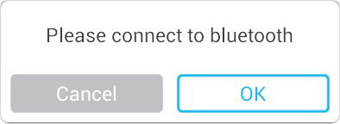

After you tap OK, the cell phone starts to search Bluetooth devices.
Ensure that the Bluetooth function is enabled.
              - Searching Bluetooth
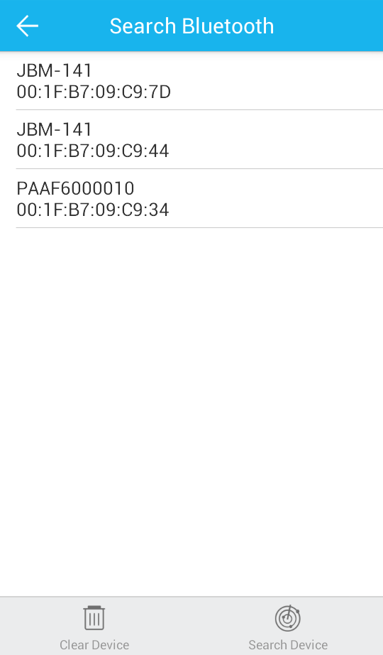
Name of the Bluetooth device

MAC address of the Bluetooth device

The Bluetooth devices paired with the cell phone are listed, as shown in Figure 1-2. If the PAT that you want to connect is not listed, tap Search Device and the app starts to scan the Bluetooth devices nearby. A device list is displayed after scanning, as shown in Figure 1-2.
The Bluetooth device list provides the name and MAC address of each Bluetooth device. The Bluetooth name of the PAT takes the form of an 11-bit MAC address begginning with “PAA”.
              - Bluetooth connection process
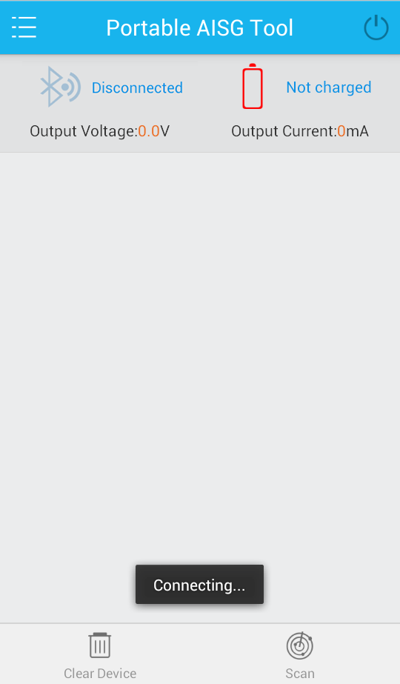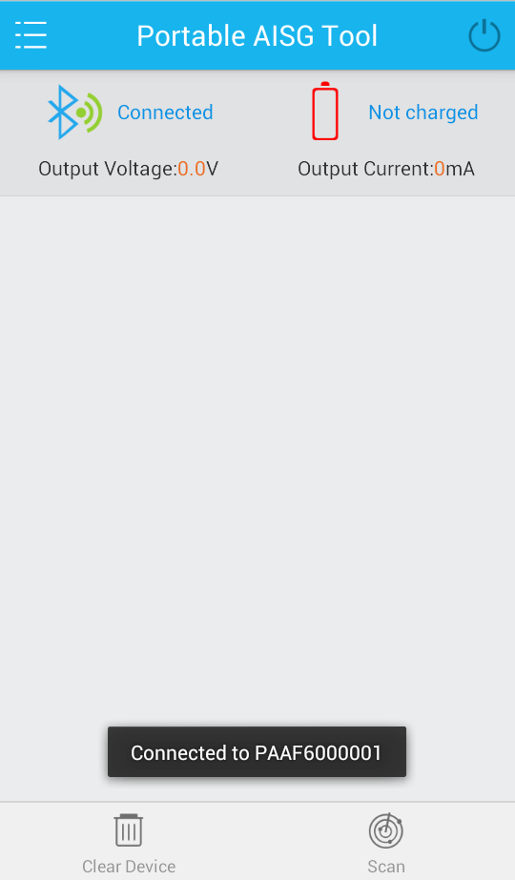

If the required PAT cannot be easily found among Bluetooth devices which have been paired with your cell phone, tap Clear Device to clear all the devices from the list. After the clearance, no Bluetooth devices that have been paired are displayed, as shown in Figure 1-4. Then, tap Search Device to search available Bluetooth devices nearby.
              - Clearing Bluetooth devices
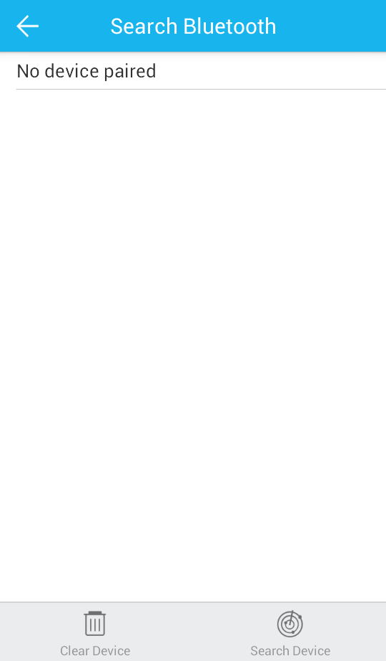

The Bluetooth devices on the app page and the record of devices paired with the cell phone will be cleared when you tap Clear Device. If the cell phone has been connected to a PAT, the communication between the cell phone and the Bluetooth on the PAT will be interrupted after this operation.

Connecting to the PAT
After the Bluetooth connection between the cell phone and PAT is set up, the app returns to its homepage and Connected is displayed, as shown in Figure 1-1.
If a new firmware version is found, the Discover new firmware dialog box is displayed, as shown in Figure 1-2. If an upgrade is required, tap OK. Otherwise, tap Cancel.
              - Connecting to the PAT
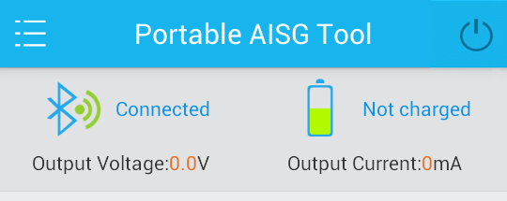

              - Finding new firmware
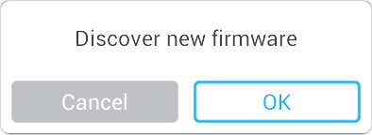

After the firmware is upgraded, the PAT will automatically shut down. You need to restart the PAT if you want to continue using it.

Enabling the External Power Supply
After the PAT connects to the ALD, you can turn on the external power switch by tapping the power button on the upper right of the page as shown in Figure 1-1. When the power supply switch turns from black to white, the external power supply switch has been turned on. Under the Bluetooth connection indicator  and the battery charging indicator , you can check the output voltage and current of the external power supply port.
              - Turning on the external power supply switch of the PAT
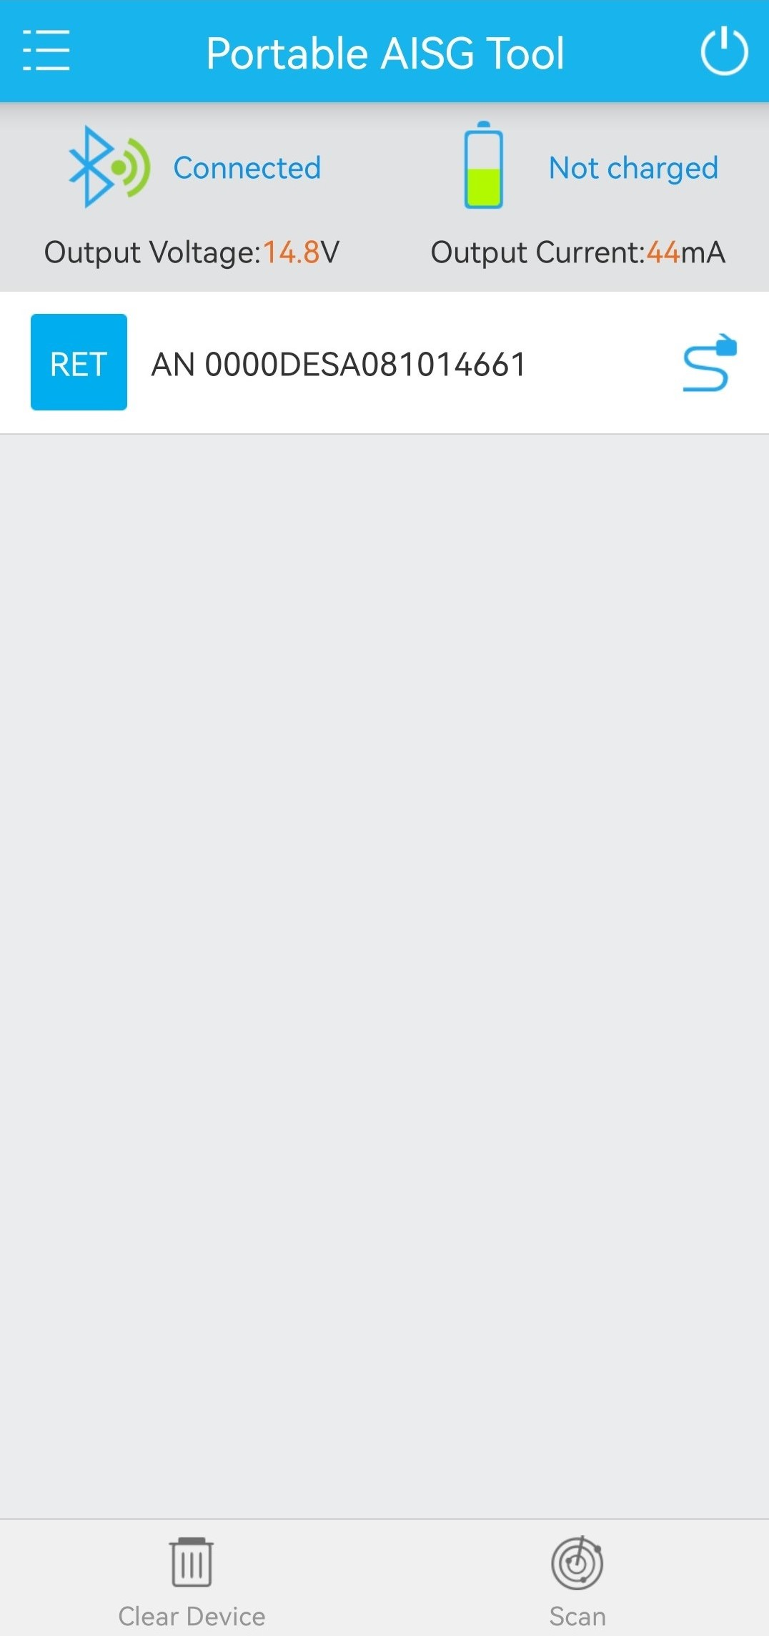

Scanning ALDs
After the communication between the cell phone and the PAT is set up, you can also tap Scan on the lower right corner of its homepage, as shown in Figure 1-1.
              - Scanning ALDs


After ALDs are detected, a device list is displayed, as shown in Figure 1-2.
Information about ALDs is described as follows:
- ALD device type: If a red exclamation mark is displayed in the upper right corner of a symbol , this device reports an alarm.
- Device SN.
- Connection state between the ALD and PAT: The blue line indicates connected and the gray line indicates disconnected.
              - Devices detected

Operating ALDs
When operating an ALD, tap the device SN shown in Figure 1-2 to enter the ALD configuration page, as shown in Figure 2-1.
              - Configuring an ALD
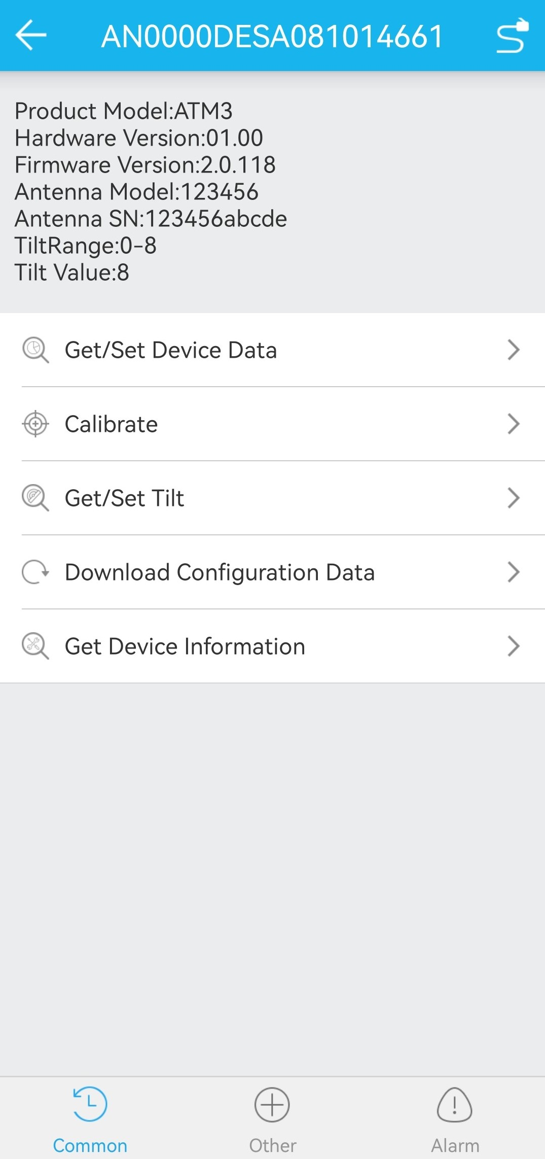
Connection status

SN of the ALD
Return button

The page is divided into three areas:
- Top area: provides the SN of the ALD, connection state (The white line indicates the connected state) and the return button.
- Middle area: provides the operation results.
- Bottom area: provides the Common, Other and Alarm buttons.
Commands for app vary with the types of ALD controlled by the PAT. Public commands and commands specific for RET, RAE, TMA, Combiner devices etc. are described in the following sections.

Commands for the RET Device

Calibrate the RET Device

Function
To calibrate the remote electrical tilt (RET) device

Procedure
Tap Common and select Calibrate. The following page is displayed. During the calibration, other operations cannot be performed. The app monitors the output voltage and current of the external power supply port and displays the result.
              - Calibrate page
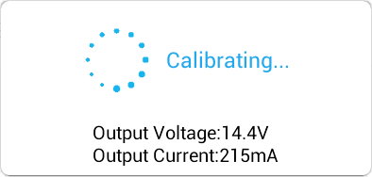

Get/Set Tilt

Function
To query and configure the downtilt of the RET device

Procedure
Tap Common and select Get/Set Tilt. The app queries the tilt of the RET device and displays the results on the page.
              - Get tilt
Only available for multi-RET antennas, not for single-RET antennas
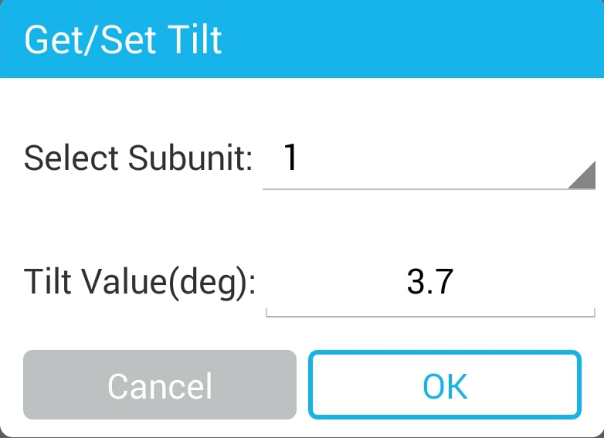

When changing the tilt of the RET device, enter the target value in the dialog box and tap OK. The following dialogue box is displayed, indicating that the PAT starts to configure the tilt of the RET device. During configuration, other operations cannot be performed on the app.
              - Set tilt
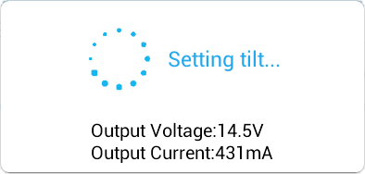

Download Configuration Data

Function
To load the configuration data related to an RET device

Procedure
Tap Common and select Download Configuration Data.
- Tap Select to select the data configuration file, and click OK to start the download.
It is recommended to load the configuration data to the path ***/luxpat on the cell phone.
              - Download configuration data
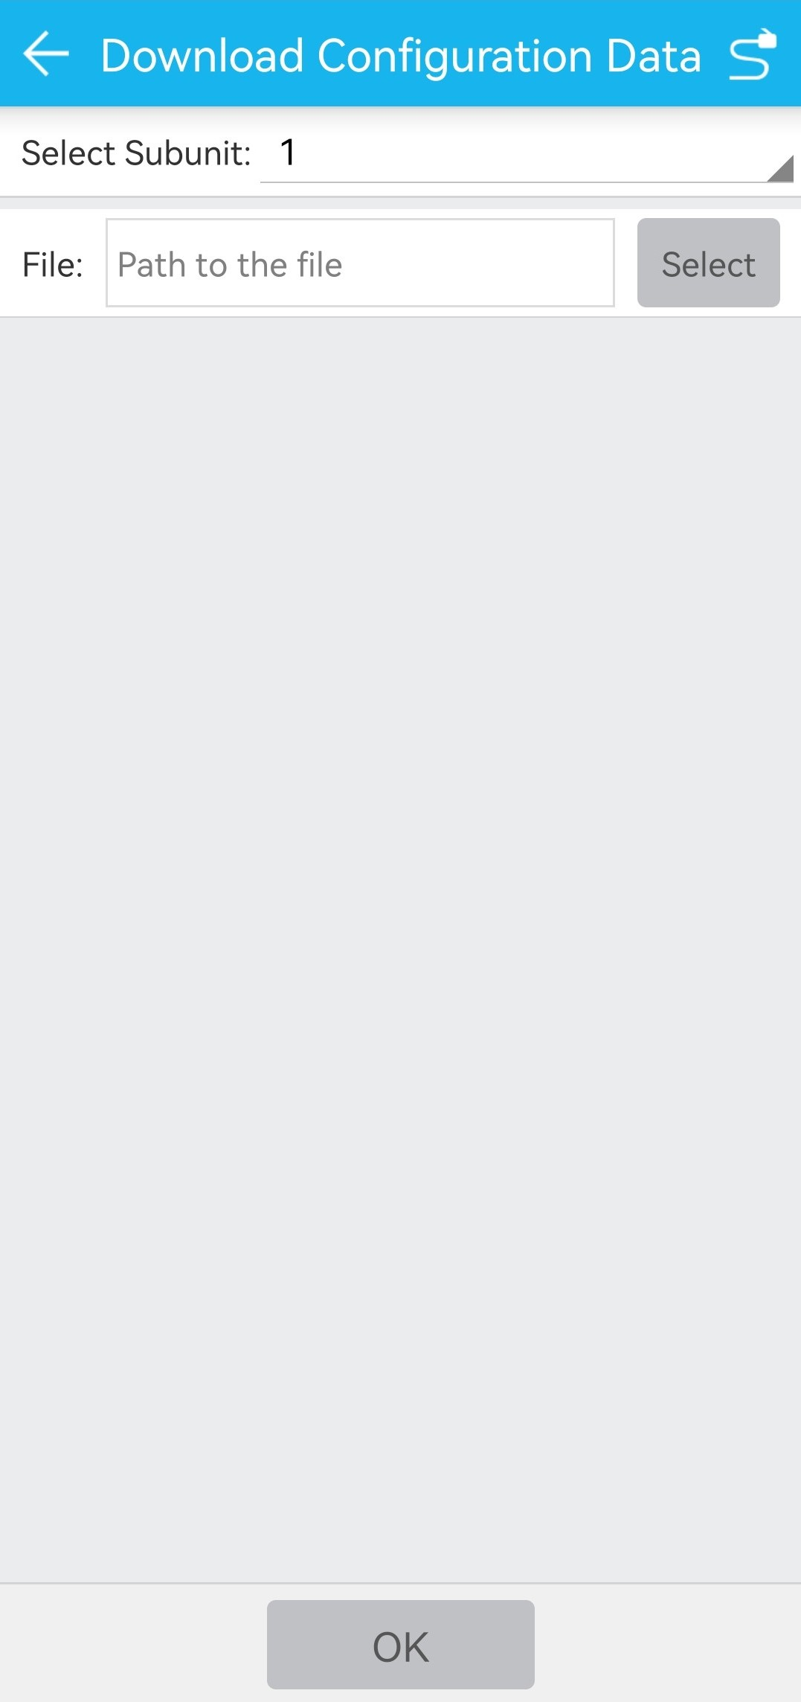
Only available for multi-RET antennas, not for single-RET antennas
Tap to select the local configuration data directory.

Commands for the RAE Device

Download RAE File

Function
To load a weighting factor file related to the RAE device

Procedure
Tap Common and select Download RAE File. A page is displayed, as shown in Figure 2-1. Select the subunit to be loaded from the drop-down list box and tap Select to select the target file.
Before loading RAE File, load it to the cell phone, and the path is recommended to be ***/luxpat.
              - Download RAE File
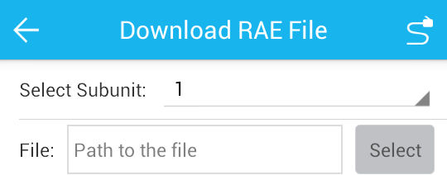

Get Weighting Factor

Function
To query the weighting factor related to antennas

Procedure
Tap Common and select Get Weighting Factor. Figure 2-1 shows the query result. You can select the subunit, tilt, broadcast beam width, or band and tap Query to query the weighting factor.
              - Get weighting factor
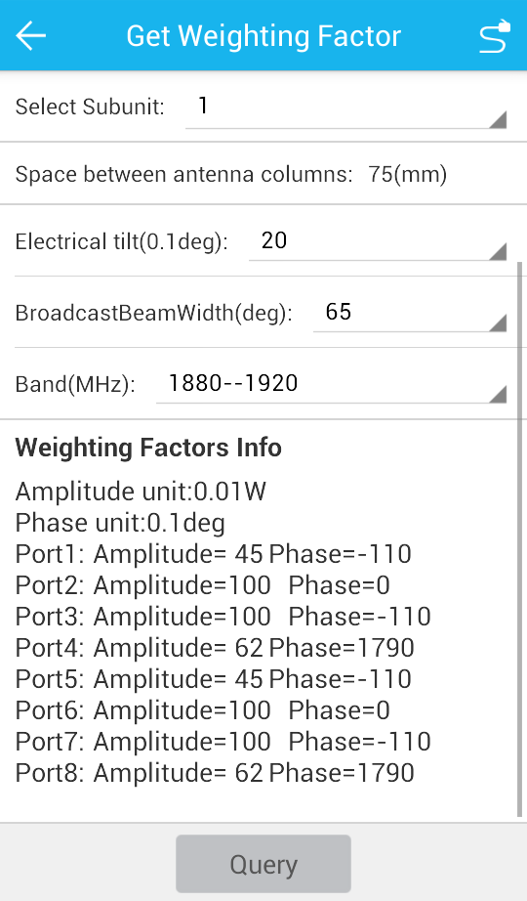

Get 2D Weighting Factor

Function
To query the two-dimensional weighting factor related to antennas

Procedure
Tap Common and select Get 2D Weighting Factor. Figure 2-1 shows the query result. You can select subunit, band, vertical beam width, horizontal beam width, downtilt, azimuth and group number, and tap Query to query the weighting factor.
              - Get 2D Weighting Factor
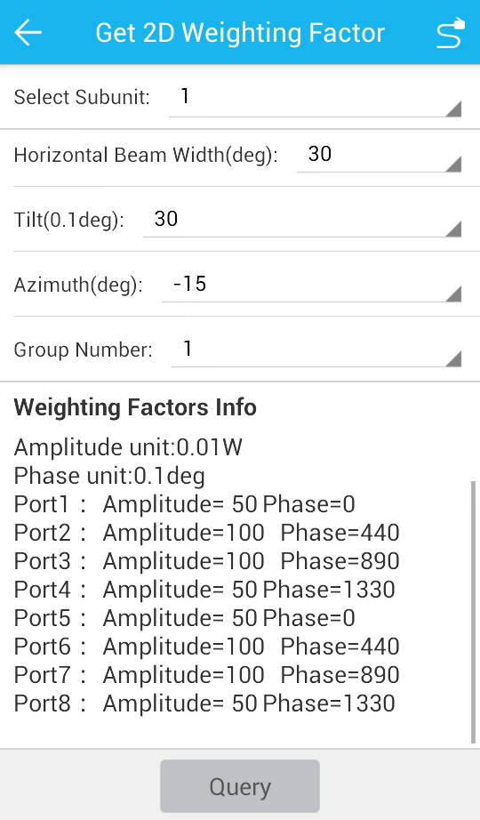

Get Supported Functions

Function
To query functions of the RAE device

Procedure
Tap Common and select Get Supported Functions. The result is displayed, as shown in Figure 2-1. Select the subunit and tap OK.
              - Get Supported Functions
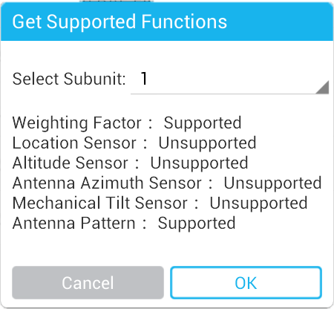

Get File Information

Function
To query the file information of the RAE device

Procedure
Tap Other and select Get File Information. The result is displayed, as shown in Figure 2-1. Select the subunit and tap OK.
              - Get file information
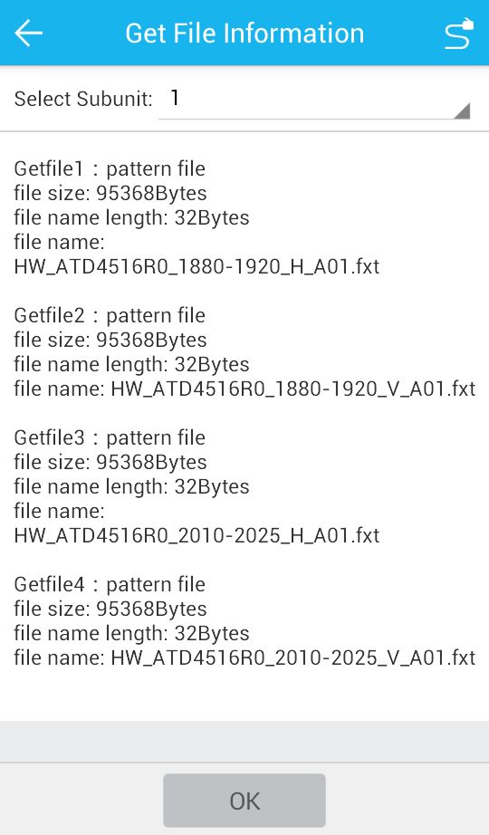

Upload RAE File

Function
To upload the weighting factor file and antenna pattern file of an RAE device to the cell phone

Procedure
Tap Other and select Upload RAE File. The result is displayed, as shown in Figure 2-1. Select subunit and the file to be loaded, and then tap Upload. After the file upload is complete, a page indicating the file storage path is displayed.
              - Upload RAE file
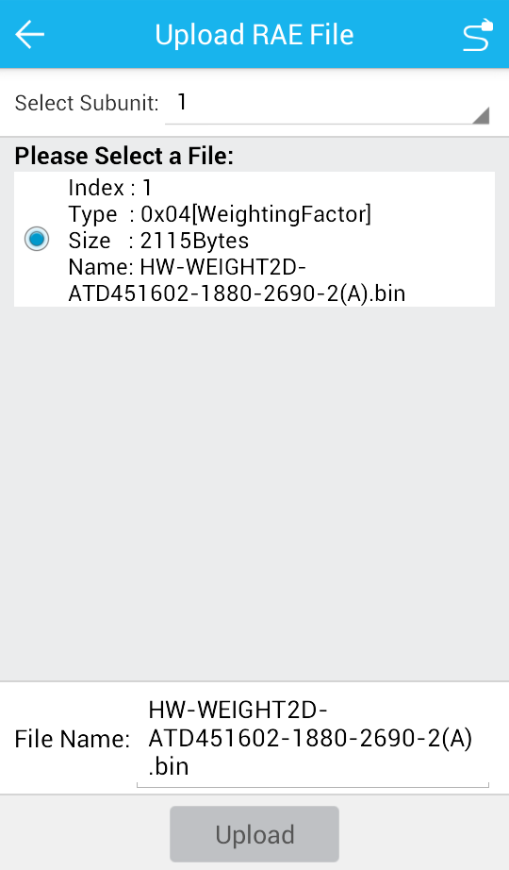

Reset to the Factory Weighting Factors

Function
To reset the weighting factor to factory settings of the RAE device

Procedure
Tap Other and select Reset to the Factory Weighting Factors. Select the subunit and tap OK.
              - Reset to the factory weighting factors
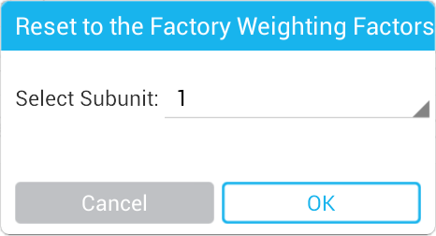

Commands for the TMA Device

TMA Mode Operation

Function
To query and set the working mode of a tower-mounted amplifier (TMA)

Procedure
Tap TMA Mode Operation under Common. The query results are displayed, as shown in Figure 2-1.
              - TMA mode operation
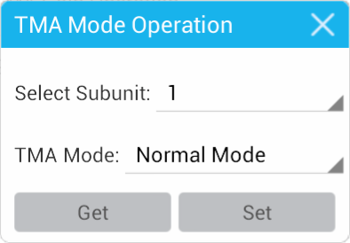

To change the TMA working mode, select a new mode from the drop-down list box, and tap Set.
To query the TMA working mode again, tap Get.

TMA Gain Operation

Function
To query the gain of the TMA

Procedure
Tap TMA Gain Operation under Common. The query results are displayed, as shown in Figure 2-1.
              - TMA gain operation
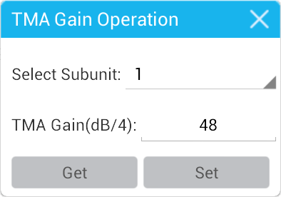

To change the TMA gain, enter a target value, and tap Set.
To query the TMA gain again, tap Get.

Get Supported Functions (Available Only for AISG 2.0 Devices)

Function
To query the supported functions of the TMA

Procedure
Tap Get Supported Functions under Common. A dialog box is displayed, as shown in Figure 2-1. Then, select a subnet from the Select Subunit drop-down list box, and tap OK.
              - Get supported functions
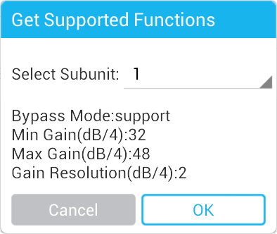

Commands for the Combiner Device

Get Device Capability

Function
To get device capability, including current work mode, combiner port number，splitter port number and port frequency.

Procedure
Tap Get Device Capability under Common. The result of device capability is shown as the example in Figure 2-1.
              - Get Device Capability
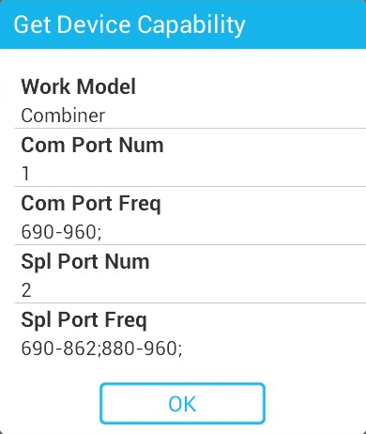

Get/Set Bypass Mode

Function
To get and set port bypass mode

Procedure
Tap Get/Set Bypass Mode under Common. A dialog box is displayed, as shown in Figure 2-1 For the setting of bypass mode, select parameter in Com Mode and Spl Mode, then tap OK, the setting mode will be actived after power reset.
              - Get/Set Bypass Mode
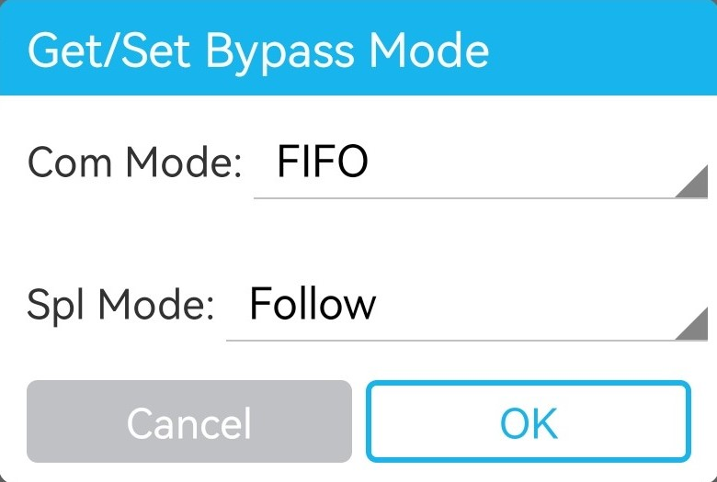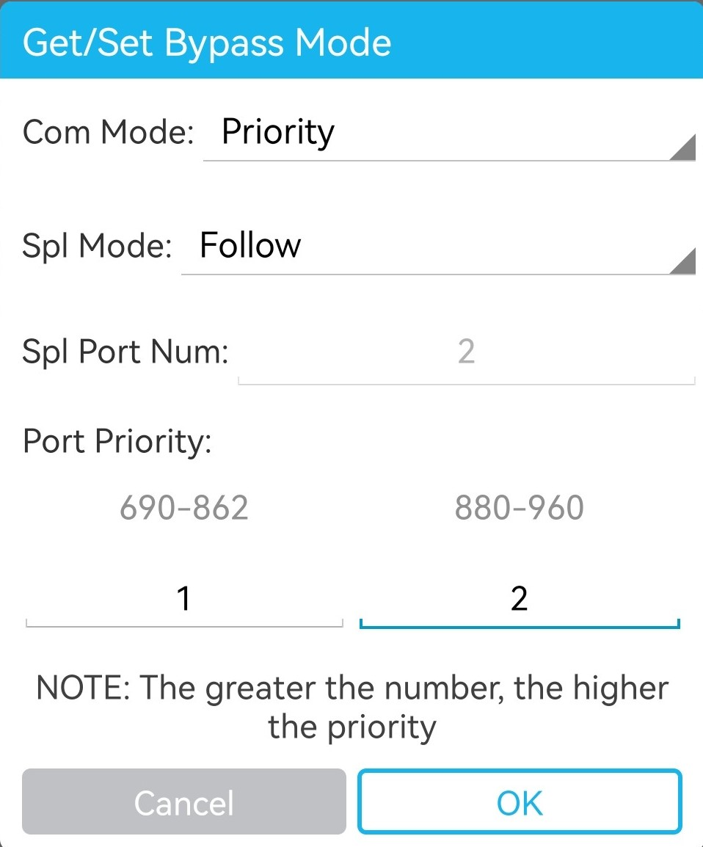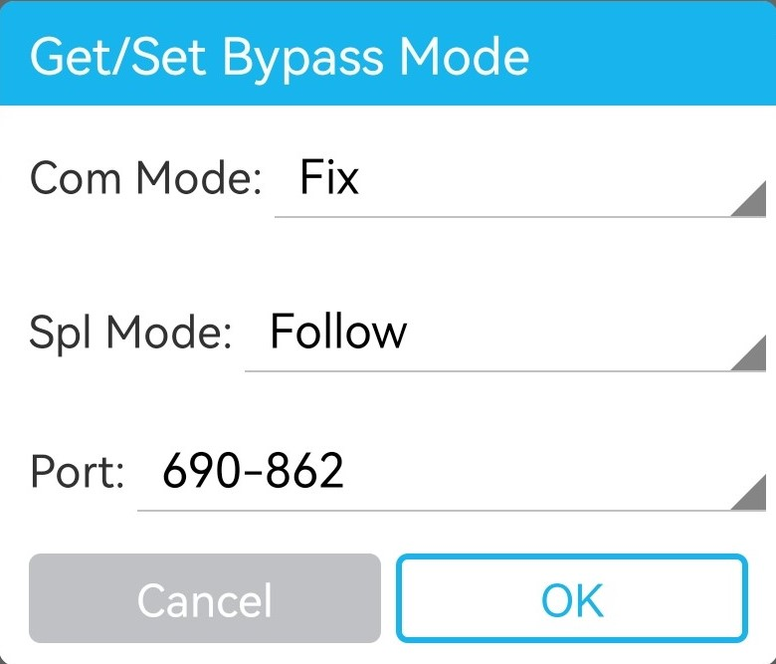

Common Commands

Get/Set the Device Data

Function
To query and set the device information and engineering parameters

Procedure
Tap Get/Set Device Data under Common. The query results are displayed, as shown in Figure 2-1.
              - Get/Set device data
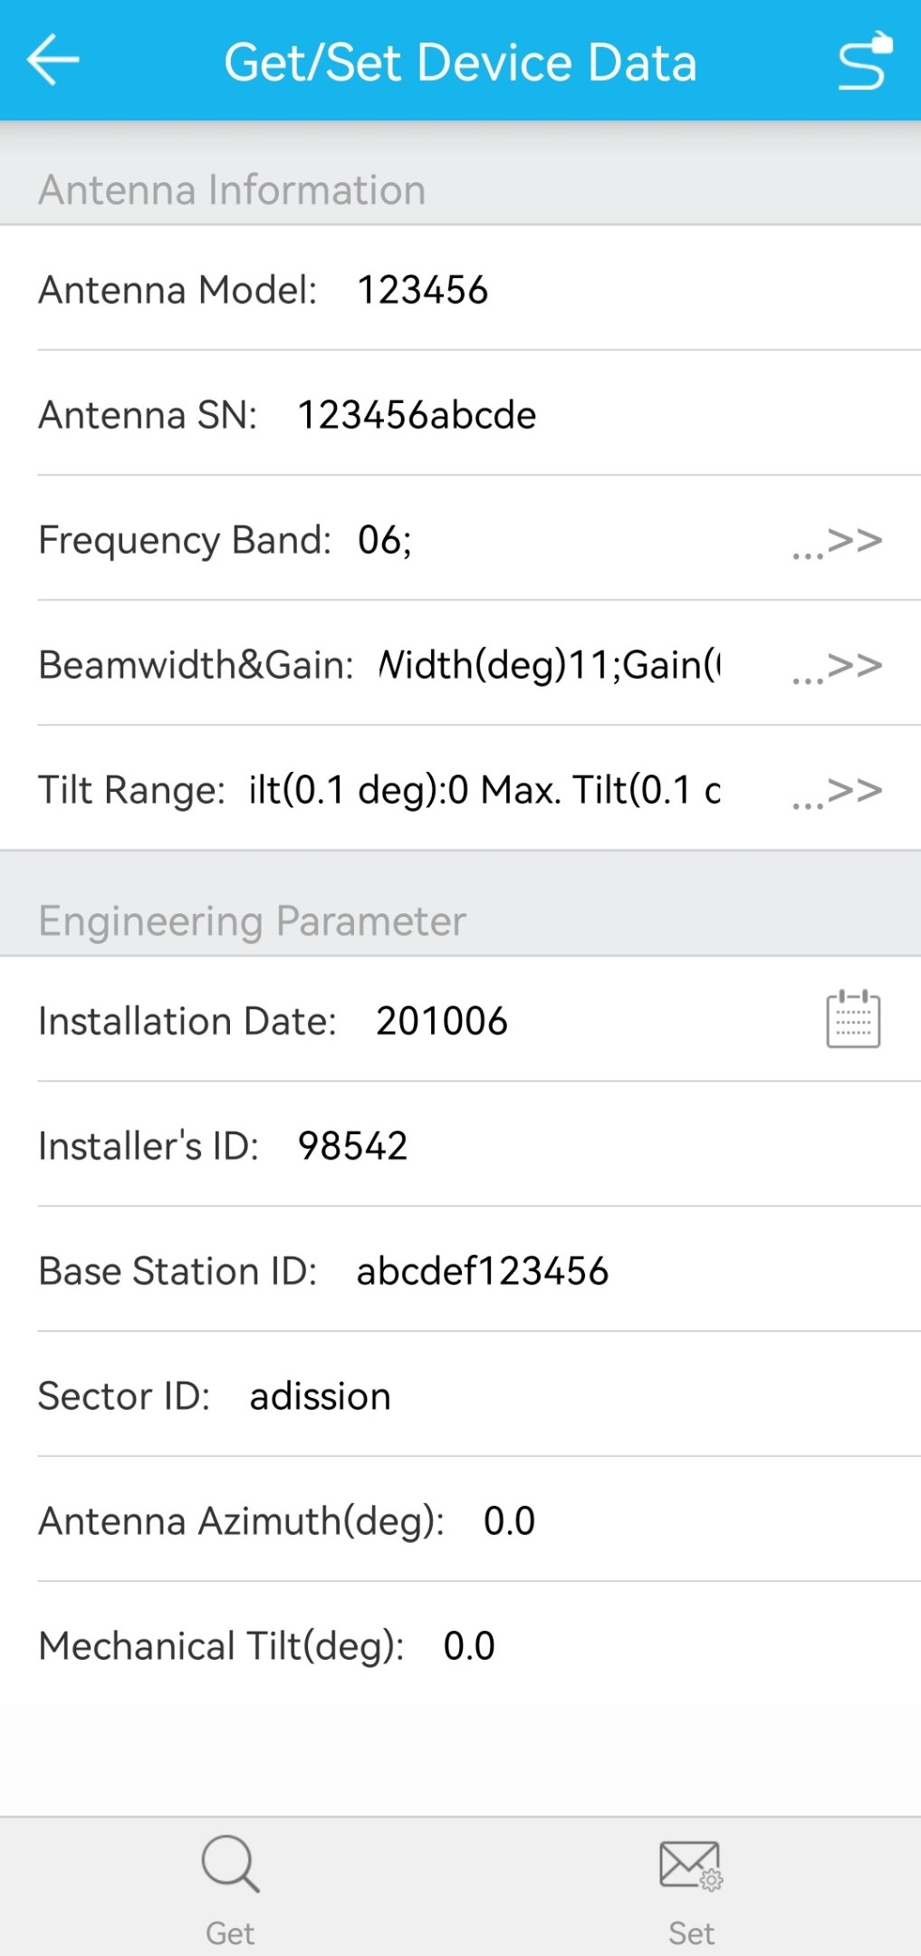

When you need to modify certain information of a device, enter the new content in the text box, and tap Set. A dialog box is displayed, indicating that the setting is successful or failed.
If the device information is not modified, the app will not respond after you tap Set.
To query device data again, tap Get.

Get Device Information

Function
To query device information

Procedure
Tap Get Device Information under Common. The device information is displayed, as shown in Figure 2-1. The device information includes the product model, SN, hardware version, software version, and AISG version.
              - Get device information
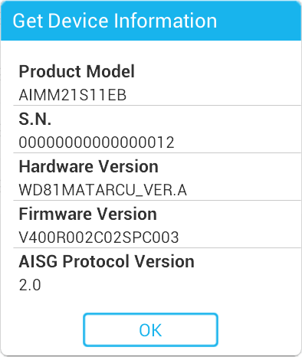

Download Software

Function
To load RET device software

Procedure
Tap Download Software under Other. A dialog box is displayed, as shown in Figure 2-1. Then, tap Select to select required software. After the software loading is complete, tap OK to return to the main interface.
            - Before loading the RET device software, it is recommended to load it to the path ***/luxpat on the cell phone.
              - Download software
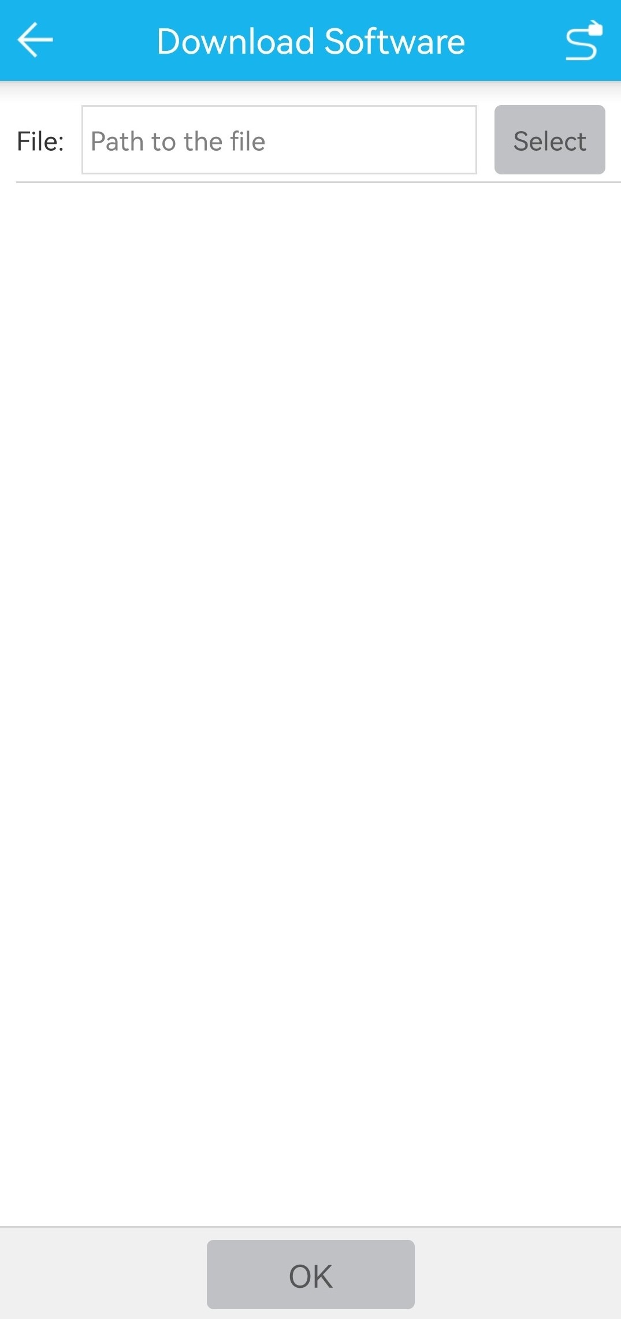

Reset Device

Function
To reset the RET devices

Procedure
Tap Reset Device under Other to reset the RET devices.
              - Reset device
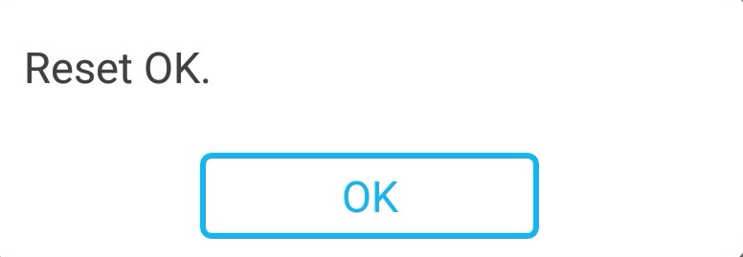

Alarms

Querying Alarms

Function
To query the alarms reported by the RET device

Procedure
On the RET device operation interface, tap Alarm to access the page that displays all alarms reported by the current RET device. Alarm information about the current RET device is described as follows:
- Alarm sequence number, displayed in the first column.
- RET device subunit, displayed in the second column only when the device has a subunit, as shown in the right figure of Figure 3-1.
- Alarm code, displayed in the third column.
- Alarm status, displayed in the fourth column.
- Alarm time, displayed in the fifth column.
              - Alarm page
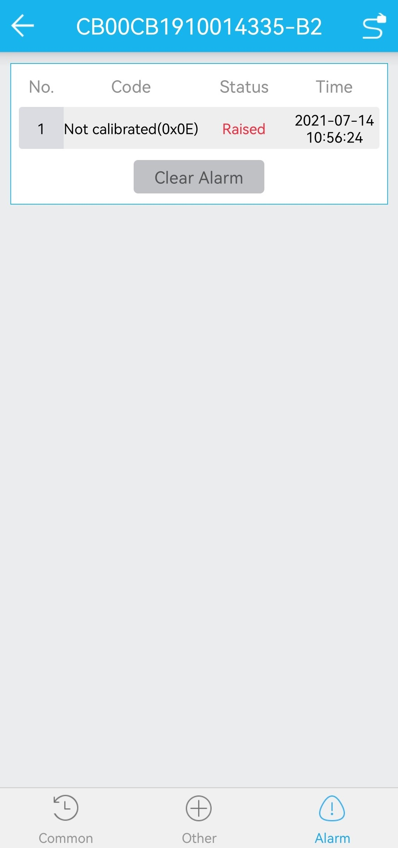

Clear Alarms

Function
To clear the alarms reported by the RET device

Procedure
Tap Clear Alarm to clear all the displayed alarms. However, the faults of the RET device are not rectified.
              - Clear alarm


Alarm Details

Function
To query the possible causes and solutions of device alarms

Procedure
Tap the reported alarm. The alarm details are displayed, as shown in Figure 3-1.
              - Alarm details
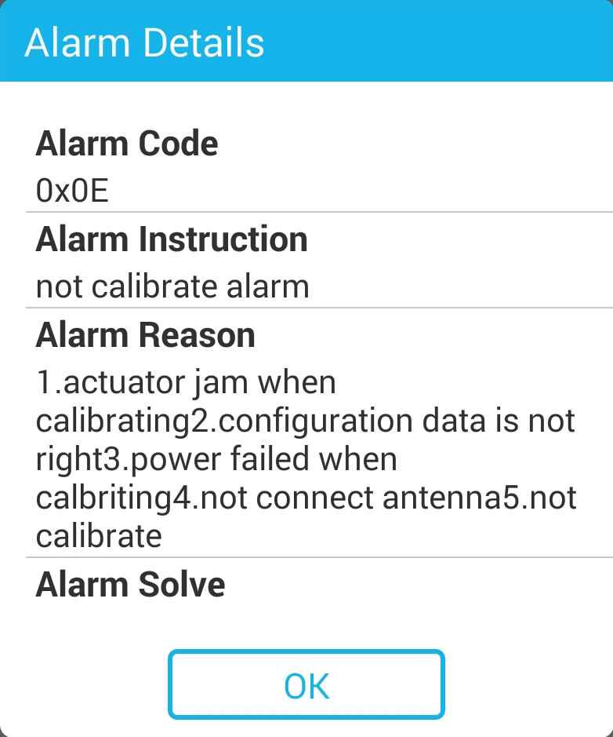

PAT Operation

Query the PAT Information

Function
To query the PAT information

Procedure
Tap in the upper left corner of the main interface, and select PAT Information from the drop-down list box. The PAT information query window is displayed, as shown in Figure 4-1.
              - Query PAT information
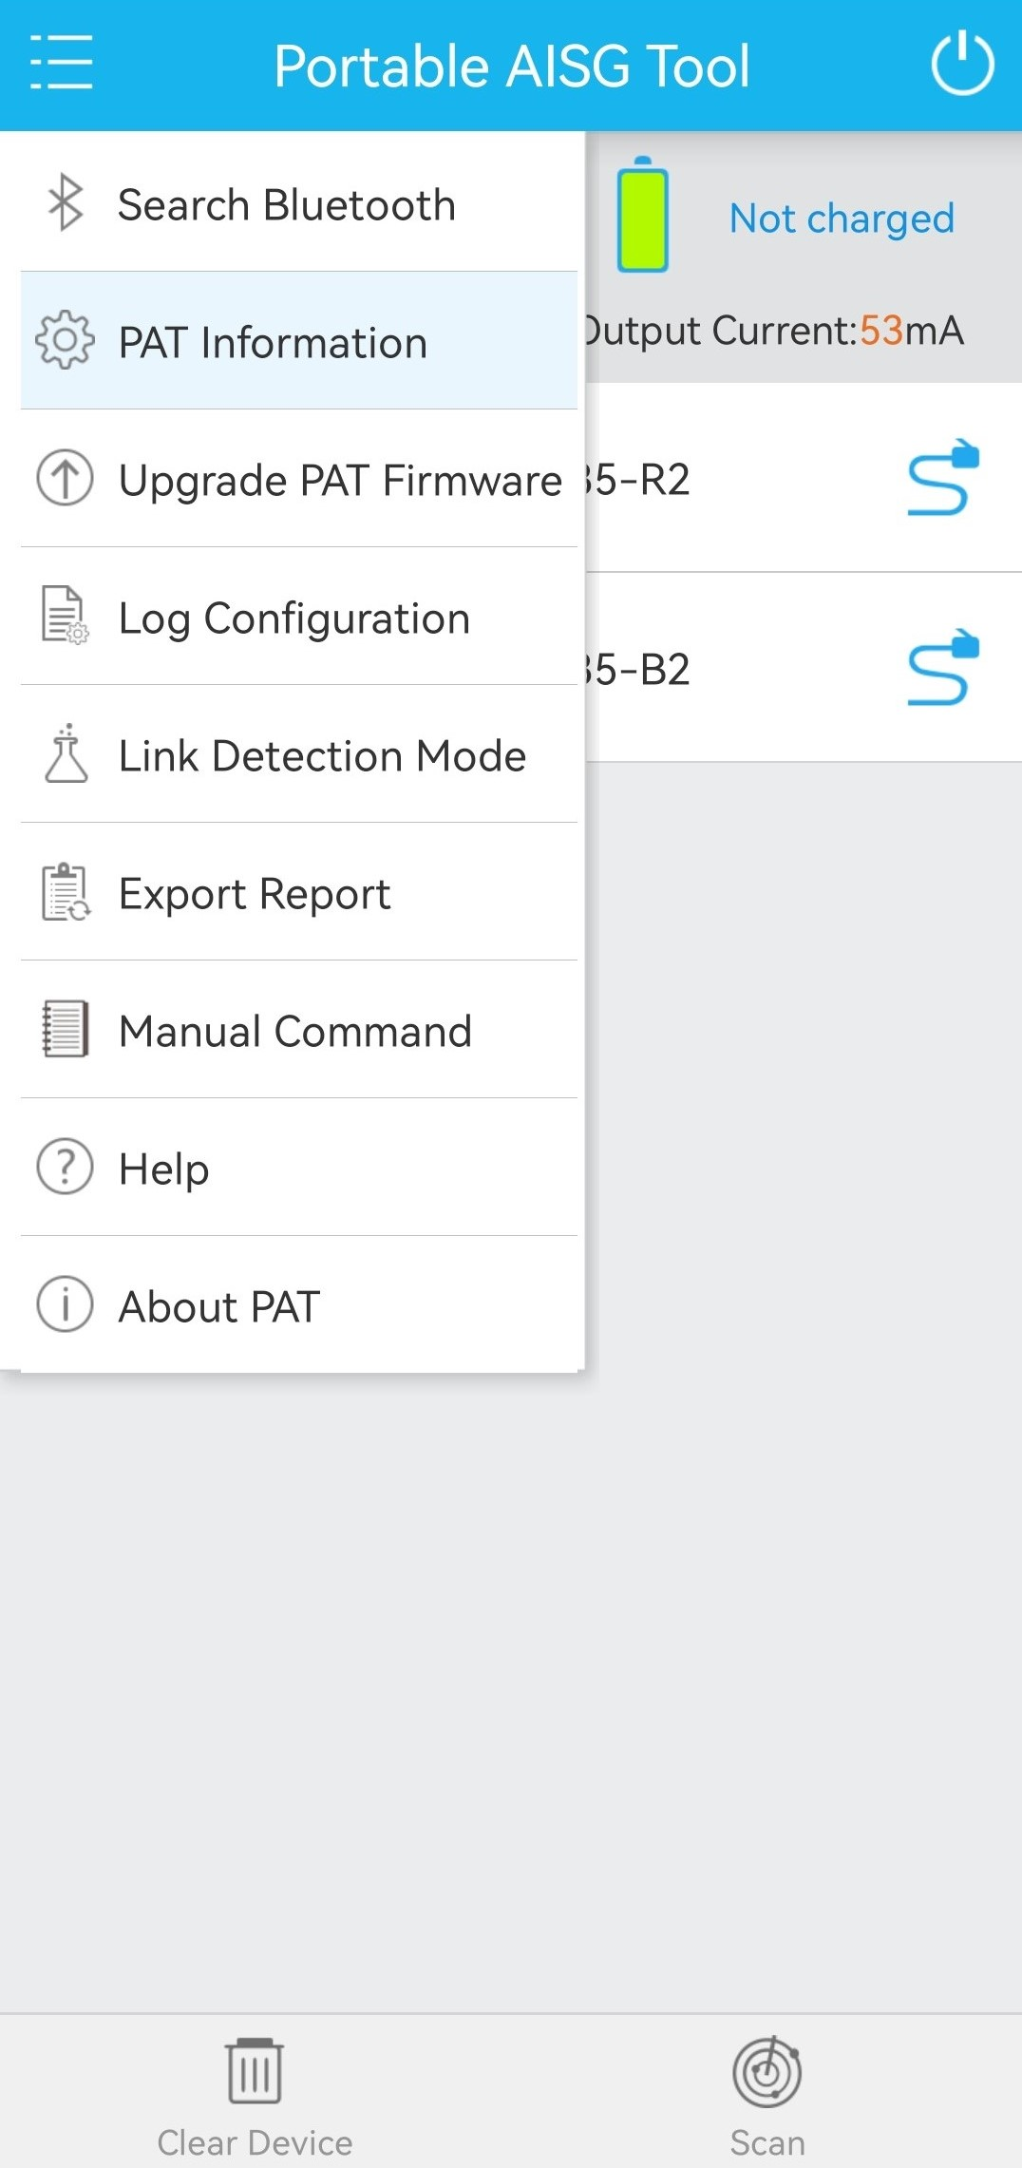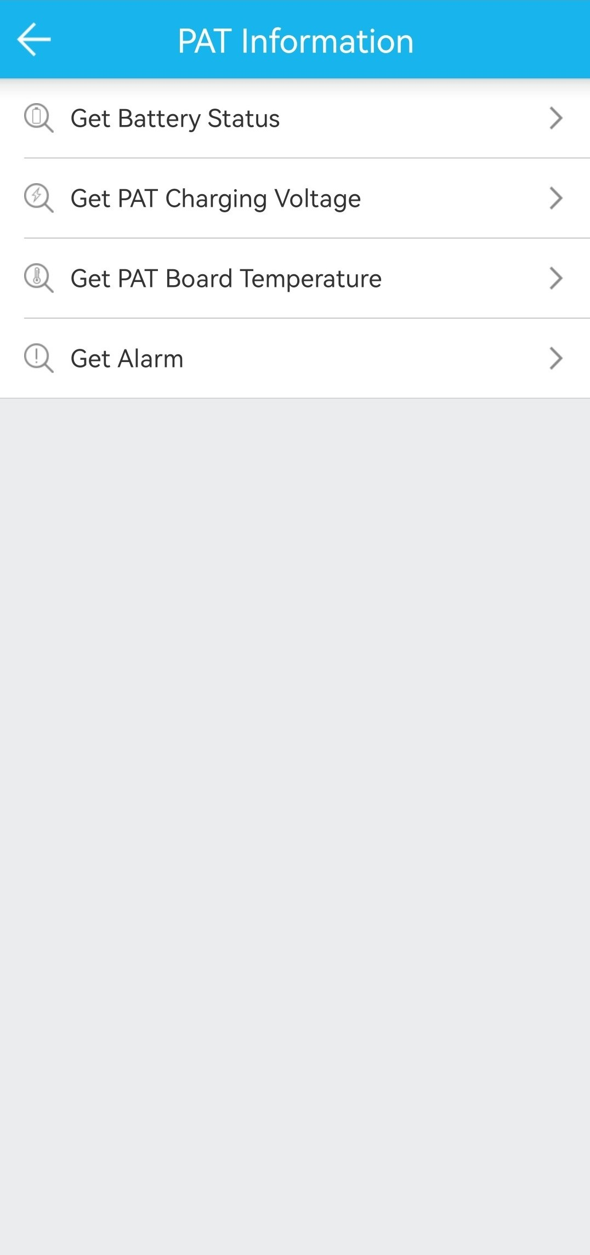

Get Battery Status

Function
To query the battery status of the PAT

Procedure
Tap Get Battery Status. The battery status of the PAT is displayed, as shown in Figure 4-1.
              - Get battery status
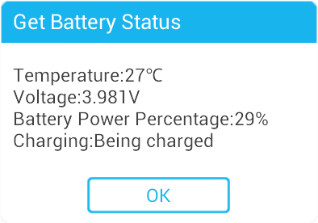

Get PAT Charging Voltage

Function
To query the current charge voltage of the PAT

Procedure
Tap Get PAT Charging Voltage. The current charge voltage of the PAT is displayed, as shown in Figure 4-1.
              - Get PAT charging voltage
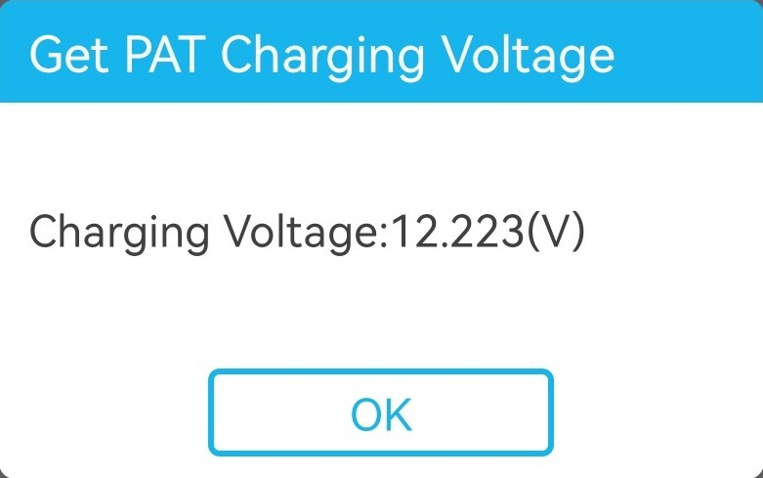

Get PAT Board Temperature

Function
To query the current temperature of the PAT board

Procedure
Tap Get PAT Board Temperature. The current temperature of the PAT board is displayed, as shown in Figure 4-1.
              - Get PAT board temperature
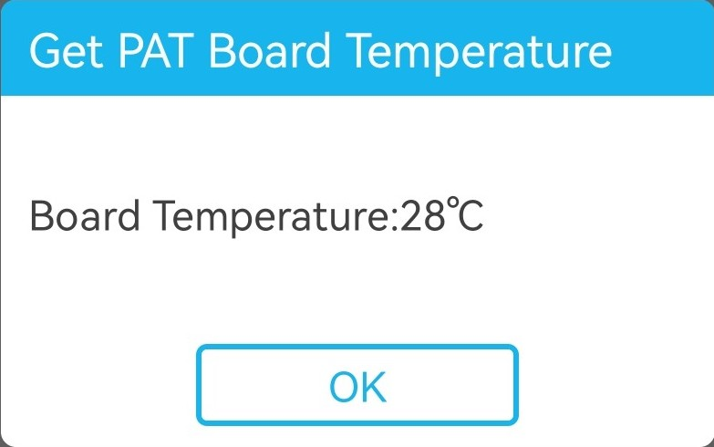

Get Alarm (for PAT device)

Function
To query the alarms reported by the PAT

Procedure
Tap Get Alarm. The alarm information of the PAT is displayed, as shown in Figure 4-1.
              - Get alarm
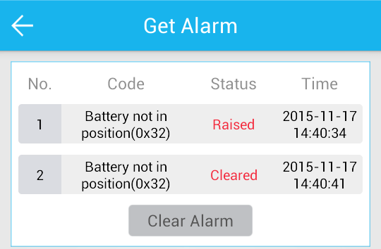

                - The alarm codes of PAT
Alarm Code | Type | Displayed Information | Remarks
0x11 | Alarm code | Hardware Error | A hardware alarm is reported.
0x30 | Alarm code | AISG/OOK Over Current | An AISG/OOK overcurrent alarm is reported.
0x32 | Alarm code | Battery Not In Position | A battery not in position alarm is reported.

Hardware Fault Alarm Handling
Background
A hardware fault alarm is reported when the flash memory or I²C bus inside the PAT is faulty.
Table 4-1 describes the hardware fault alarm.
                - Hardware fault alarm
Symptom | Impact on the System | Severity | Cause
This alarm is reported when the flash memory or I²C bus inside the PAT is faulty. In this situation, the alarm indicator is steady on. This alarm can be queried using the PAT app. | The data storage or read functions, such as battery status query and board temperature query, may be faulty. | Major | - The read/write function of the flash memory is faulty.  - The flash memory fails.  - The I²C bus is faulty.  - The I²C bus fails.

Procedure
Restart the PAT.
- If the PAT communicates properly with the smartphone and the alarm is cleared after the restart, no further actions are required.
- If the alarm persists, the PAT has been damaged. In this case, replace the PAT with a new one or contact Luxshare technical support.

AISG/OOK Overcurrent Alarm Handling
Background
If the ALD connected to the AISG or OOK port on the PAT has overly strong current or is short-circuited, the PAT forcibly shuts down the external power supply and an AISG/OOK overcurrent alarm is reported.
Table 4-1 describes the AISG/OOK overcurrent alarm.
                - AISG/OOK overcurrent alarm
Symptom | Impact on the System | Severity | Cause
If the ALD connected to the AISG or OOK port on the PAT has overly strong current or is short-circuited, the AISG/OOK overcurrent alarm is reported. In this situation, the PAT forcibly shuts down the external power supply and the alarm indicator is steady on. This alarm can be queried using the PAT app. | The ALD cannot be connected or controlled for software uploading, device information query, or other purposes. | Major | - The instantaneous current is overly strong during hot swapping.  - The number of ALDs connected to the PAT is too large, or the operating current of the ALD is excessively strong.  - The ALD is short circuited.  - The ALD experiences a hardware fault.  - The PAT is faulty.

Procedure
          - Tap the external power supply switch on the PAT app to turn on the external power supply from the PAT again.
- No further actions are required if the external power supply is successfully turned on, the PAT communicates successfully with the ALD, and the alarm is cleared.
- After the power supply switch is turned on, the PAT forcibly shuts down the external power supply. If the alarm still persists, go to Step 2.
          - Check whether the communication link or any device is short-circuited.
- If a short circuit occurs, rectify the fault and then turn on the external power supply from the PAT again. If the alarm is cleared, no further actions are required. If the alarm persists, go to Step 3.
- If no short circuit occurs, go to Step 3.
          - Check whether the total working current of all the ALDs connected to the PAT exceeds 1 A.
- If the total current is not greater than 1 A, go to Step 4.
- If the total current is greater than 1 A, decrease the number of ALDs so that the total current is equal to or less than 1 A, and then turn on the external power supply from the PAT. If the alarm is cleared, no further actions are required. If the alarm persists, go to Step 4.
          - Replace the faulty ALD and then turn on the external power supply from the PAT again.
- If the alarm is cleared, no further actions are required.
- If the alarm persists, replace the PAT. If the alarm is cleared after the replacement, no further actions are required. If the alarm persists, contact Luxshare technical support.

Battery Not in Position Alarm Handling
Background
The PAT reports a battery not in position alarm upon detecting that the battery circuit is in poor contact.
Table 4-1 describes the battery not in position alarm.
                - Battery not in position alarm
Symptom | Impact on the System | Severity | Cause
The PAT reports a battery not in position alarm upon detecting that the battery circuit is in poor contact. In this situation, the alarm indicator is steady on. This alarm can be queried using the PAT app. | If the external power supply of the PAT is insufficient or becomes unavailable, the ALD connected to the PAT cannot be calibrated or the downtilt cannot be set. At the same time, the battery power and temperature cannot be measured and the possibility of battery self-locking increases. | Minor | The battery connector inside the PAT is loosely connected or in poor contact.
Procedure
Contact Luxshare technical support so that the PAT can be disassembled or returned to Luxshare for maintenance.

Upgrade PAT Firmware

Function
To complete the software upgrade of the PAT

Procedure
Tap Upgrade PAT Firmware. A page is displayed, as shown in Figure 4-1. Tap Select to select a PAT for software upgrade, and tap OK.
              - Upgrade PAT Firmware
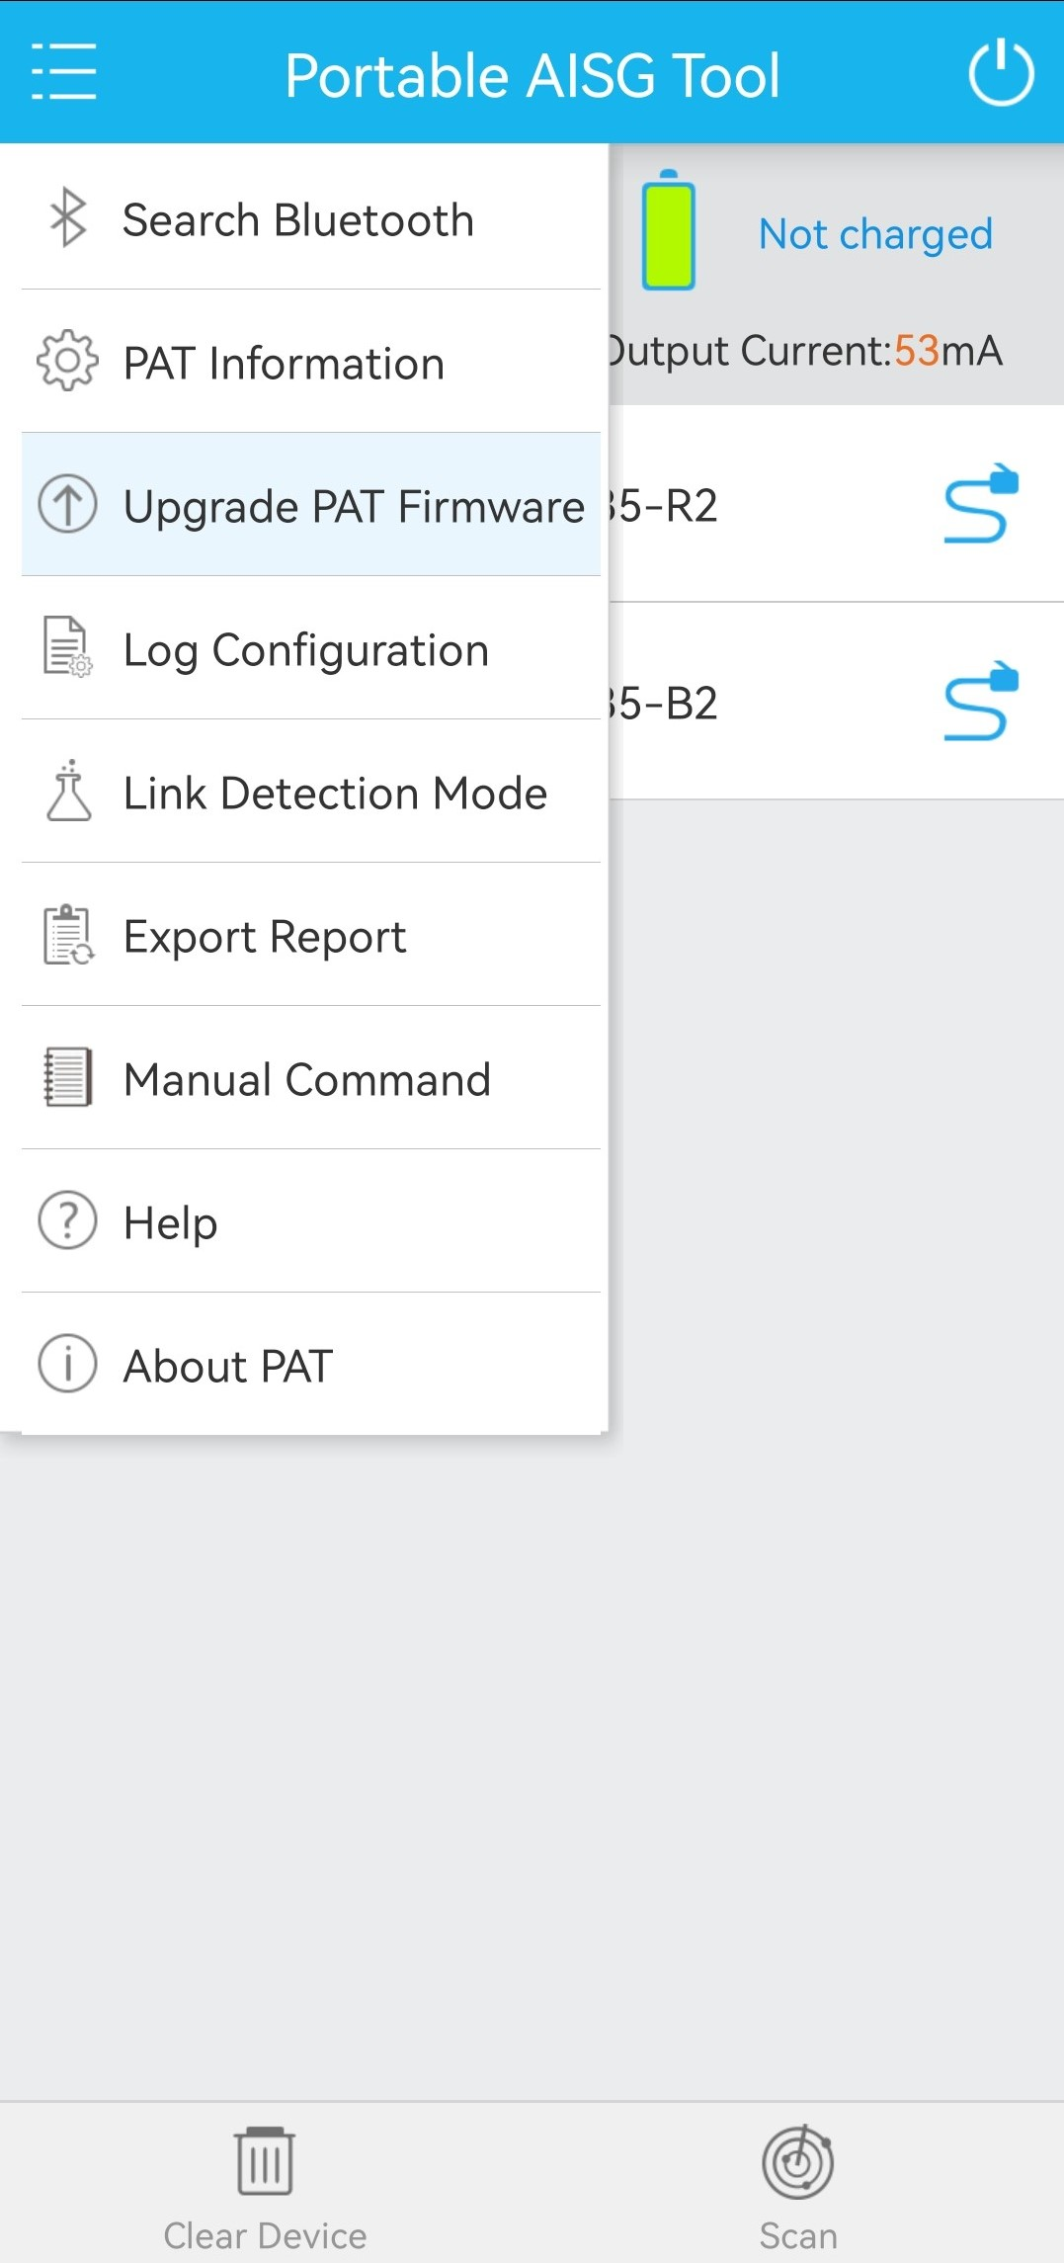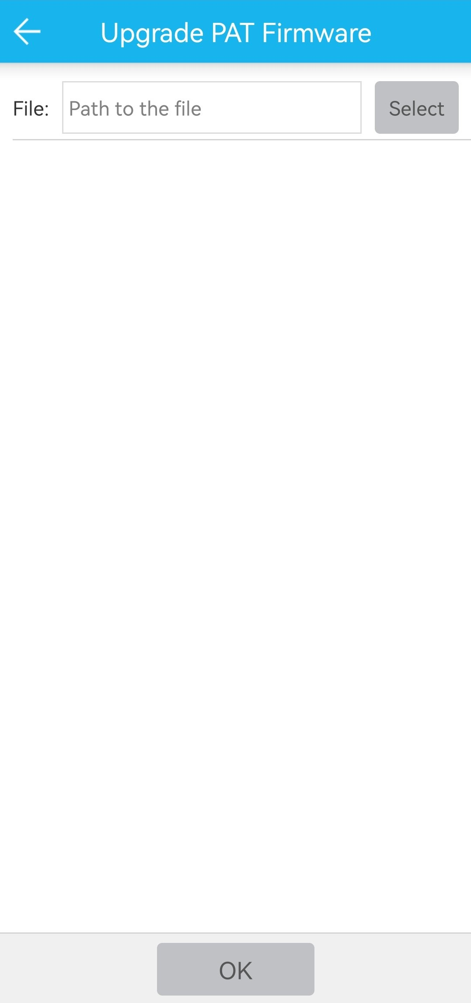

            - Before upgrade the PAT software, load it to the cell phone, and the path is recommended to be ***/luxpat.

Log Configuration

Function
To configure whether to save the original Layer 2 messages of the AISG protocol
There are three types of logs: fault, operation, and working logs. These logs are stored in the ***/luxpat/logFiles directory, and the file names are FaultLog-(date YYYY-MM-DD).txt, OperationLog-(YYYY-MM-DD).txt, and WorkingLog-(date YYYY-MM-DD).txt. If the Save Layer2 Message option is selected, Layer 2 information and fault information are saved in the fault logs.

Procedure
Tap Log Configuration. A page is displayed, as shown in Figure 4-1. Tap OK. The app starts saving the bottom-layer data to your phone.
You can select the Save Layer2 Message option to save the original Layer 2 messages, which are used to trace software operation and internal status for fault locating. By default, this option is disabled. A large number of logs may be generated based on the status of the RET device. More logs may be generated after the Save Layer2 Message option is selected. You need to clear the unnecessary logs manually.
              - Log configuration
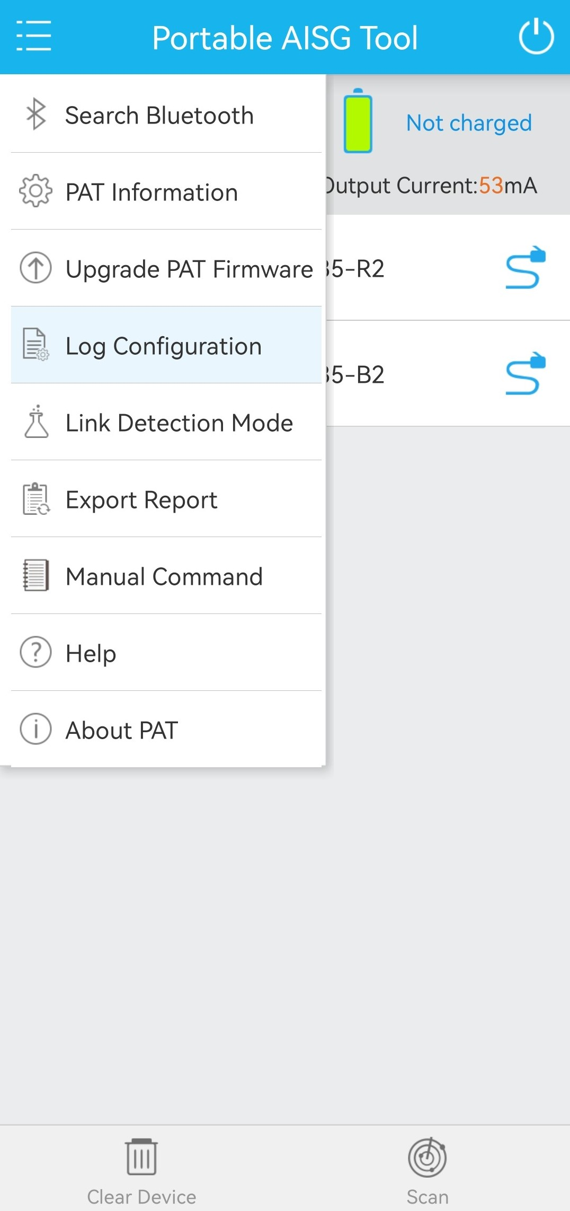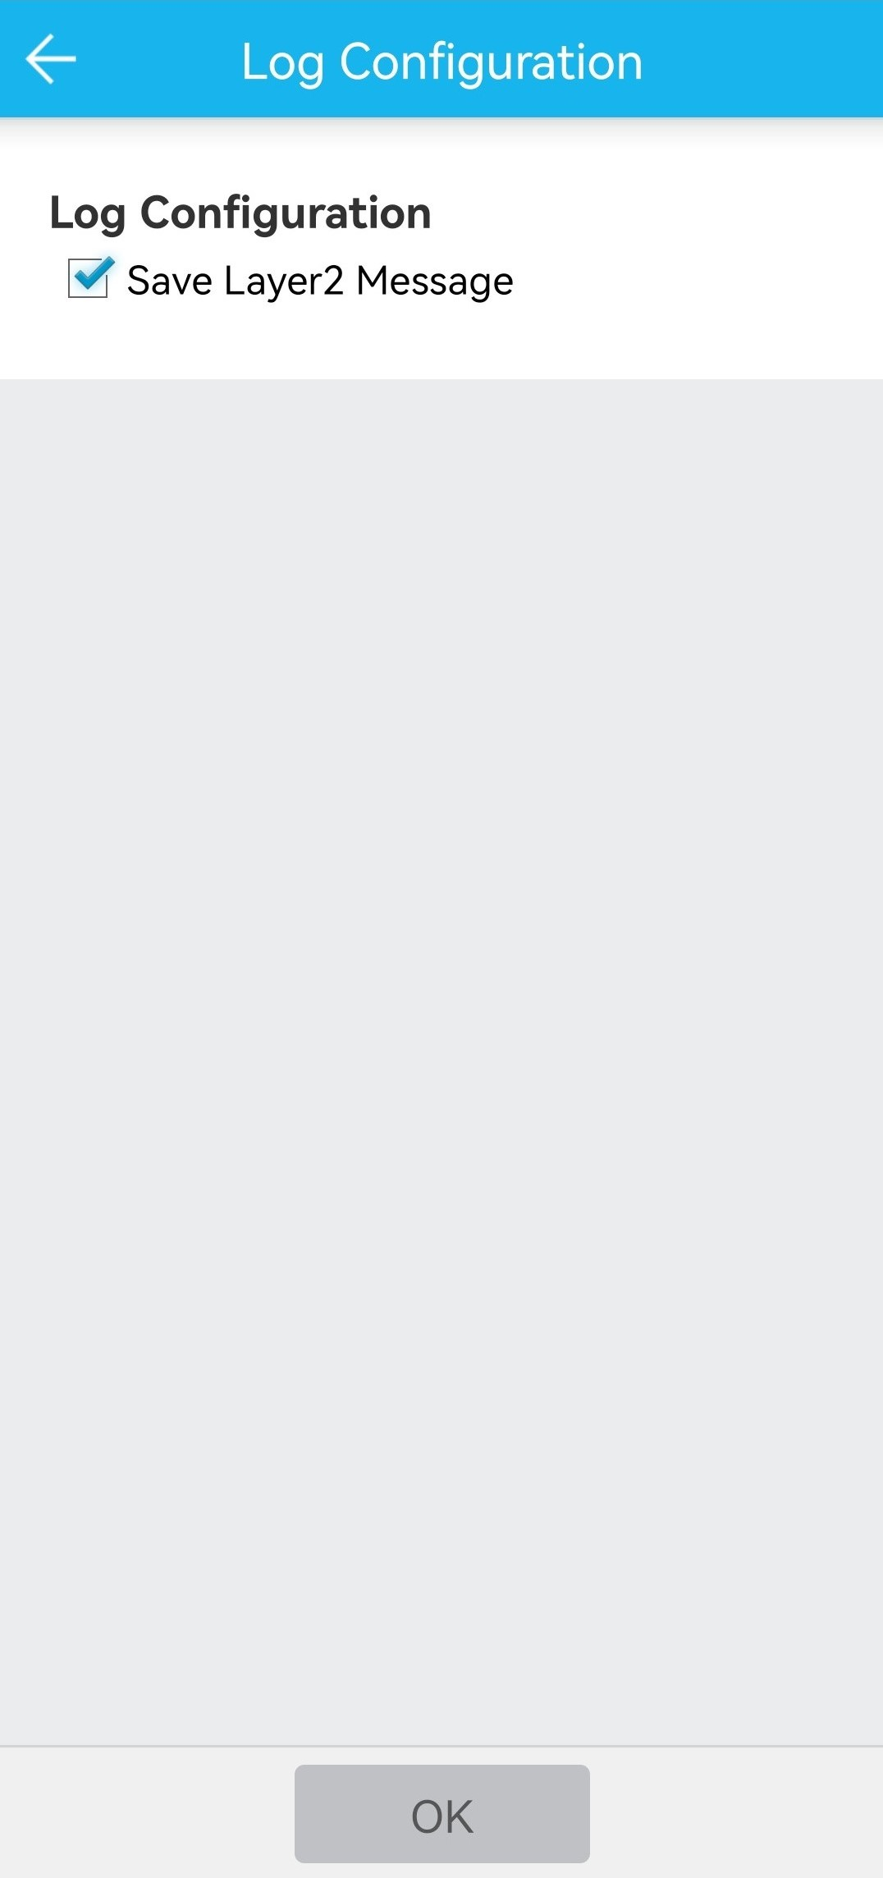

Link Detection Mode

Function
PAT can be used as a link monitoring tool to detect the voltage and data on the AISG bus. After entering the link detection mode, the PAT no longer functions as a main device but rather a monitoring device mounted to the bus to display all the data on the bus to users, and to save the data to ***/luxpat/logFiles/LinkDetectLog-(date YYYY-MM-DD).txt .

Procedure
Tap Link Detection Mode. A page is displayed, as shown in 2. The app enters the link detection mode, and the communication data on the bottom-layer link is displayed.
To change the baudrate, tap at the upper right corner, as shown in 2. On the Set Baudrate dialog box, set the baudrate, as shown in Figure 4-2.
            - In the link detection mode, the app enables the PAT to connect to the ALD link, to detect the bottom-layer data on the external communication link.
            - Do not tap the scan button to prevent the impact on external links when the links are transmitting data.
              - Link detection mode
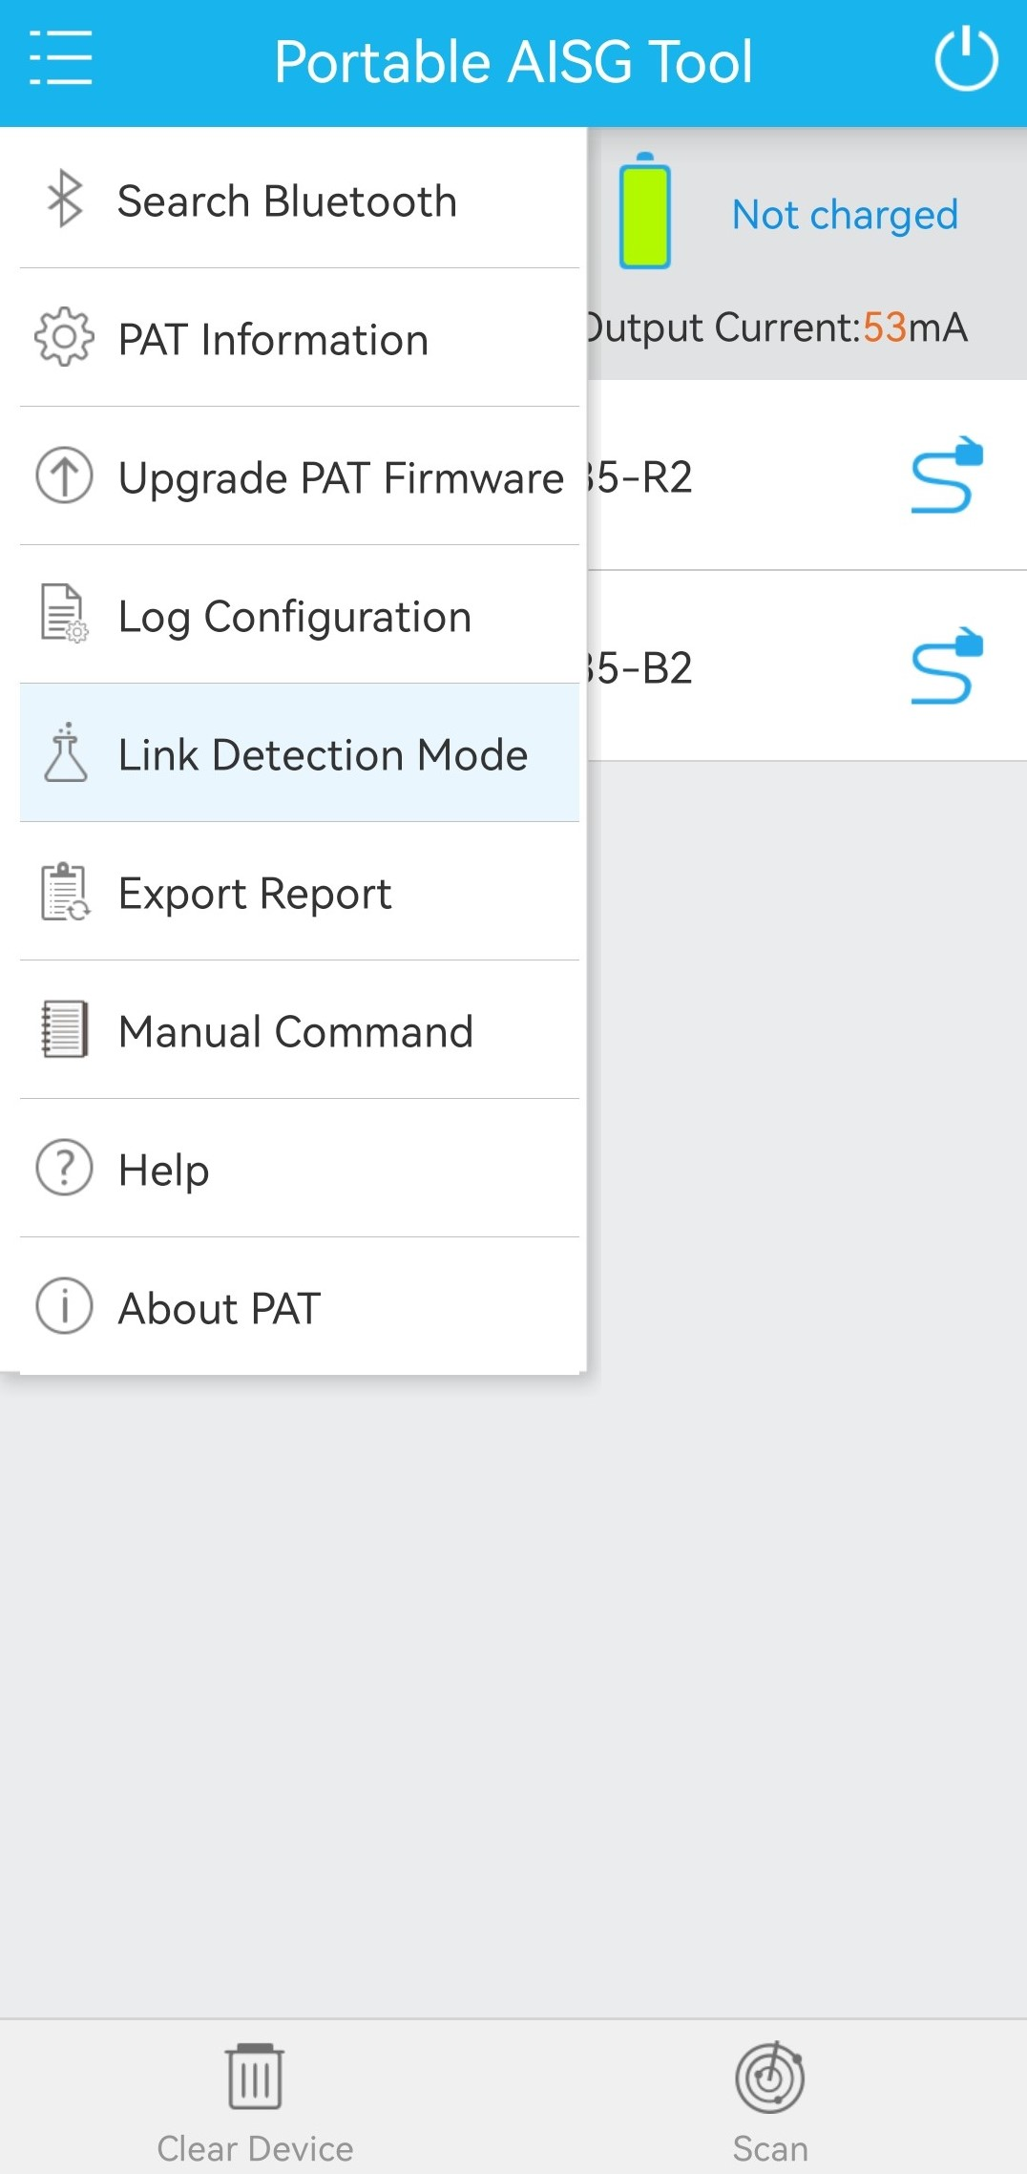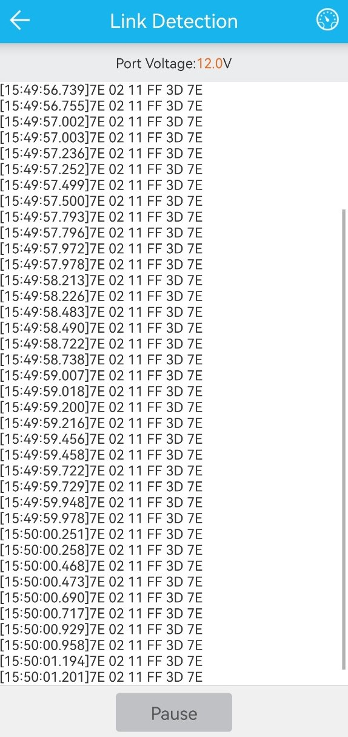

              - Set baudrate
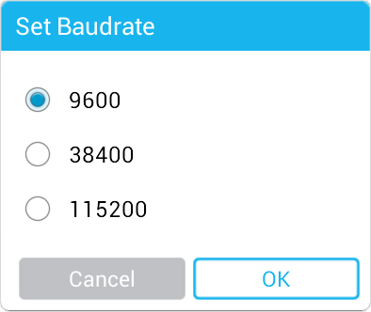

Set the baudrate is same to the AISG bus baudrate.

Export Report

Function
To export the device report containing the device model, software and hardware versions, and installation information

Procedure
Tap Export Report, and select the devices to be exported in the Select Export Device dialog box. The exported report file is stored in a folder named by the report generation time at ***/luxpat/report and is named report-(HH-MM-SS).txt.
              - Report export
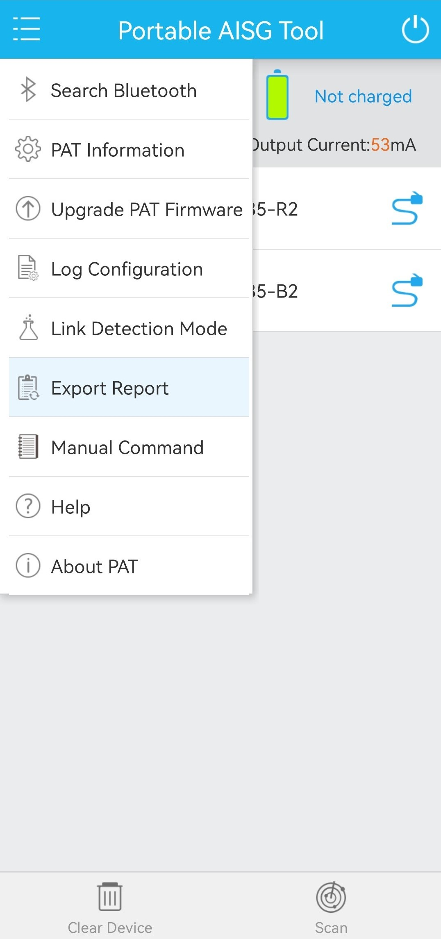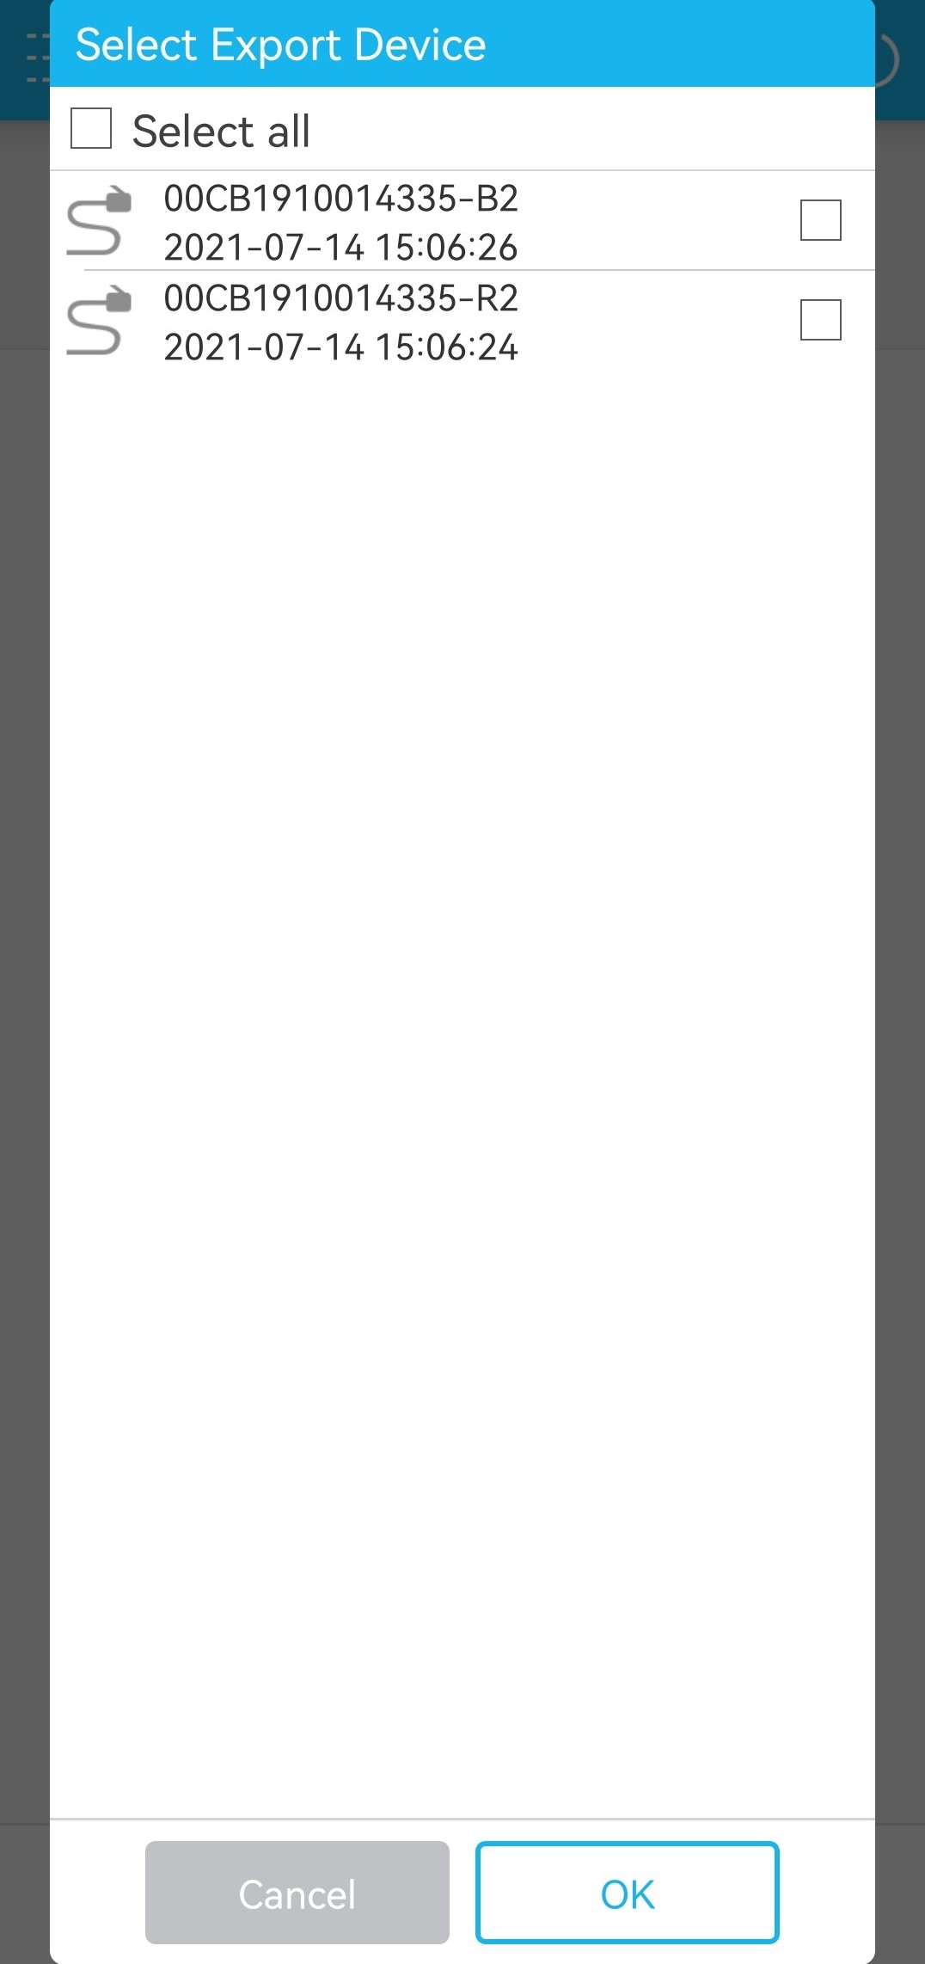

Manual Command

Function
To edit command frames for device management and receive responses from the device
This function is recommended only for engineers familiar with 3GPP specifications.

Procedure
Tap Manual Command. In the Manual Command dialog box, select the target device, configure the frame type, complete message information, and click OK. A response message will be received later.
              - Manual command
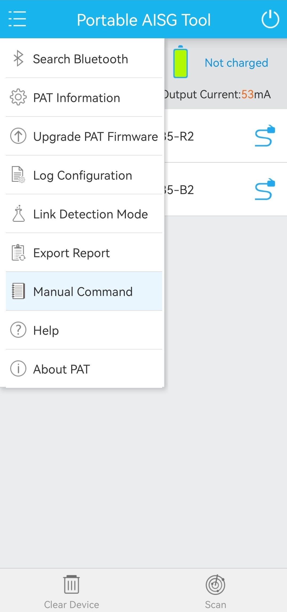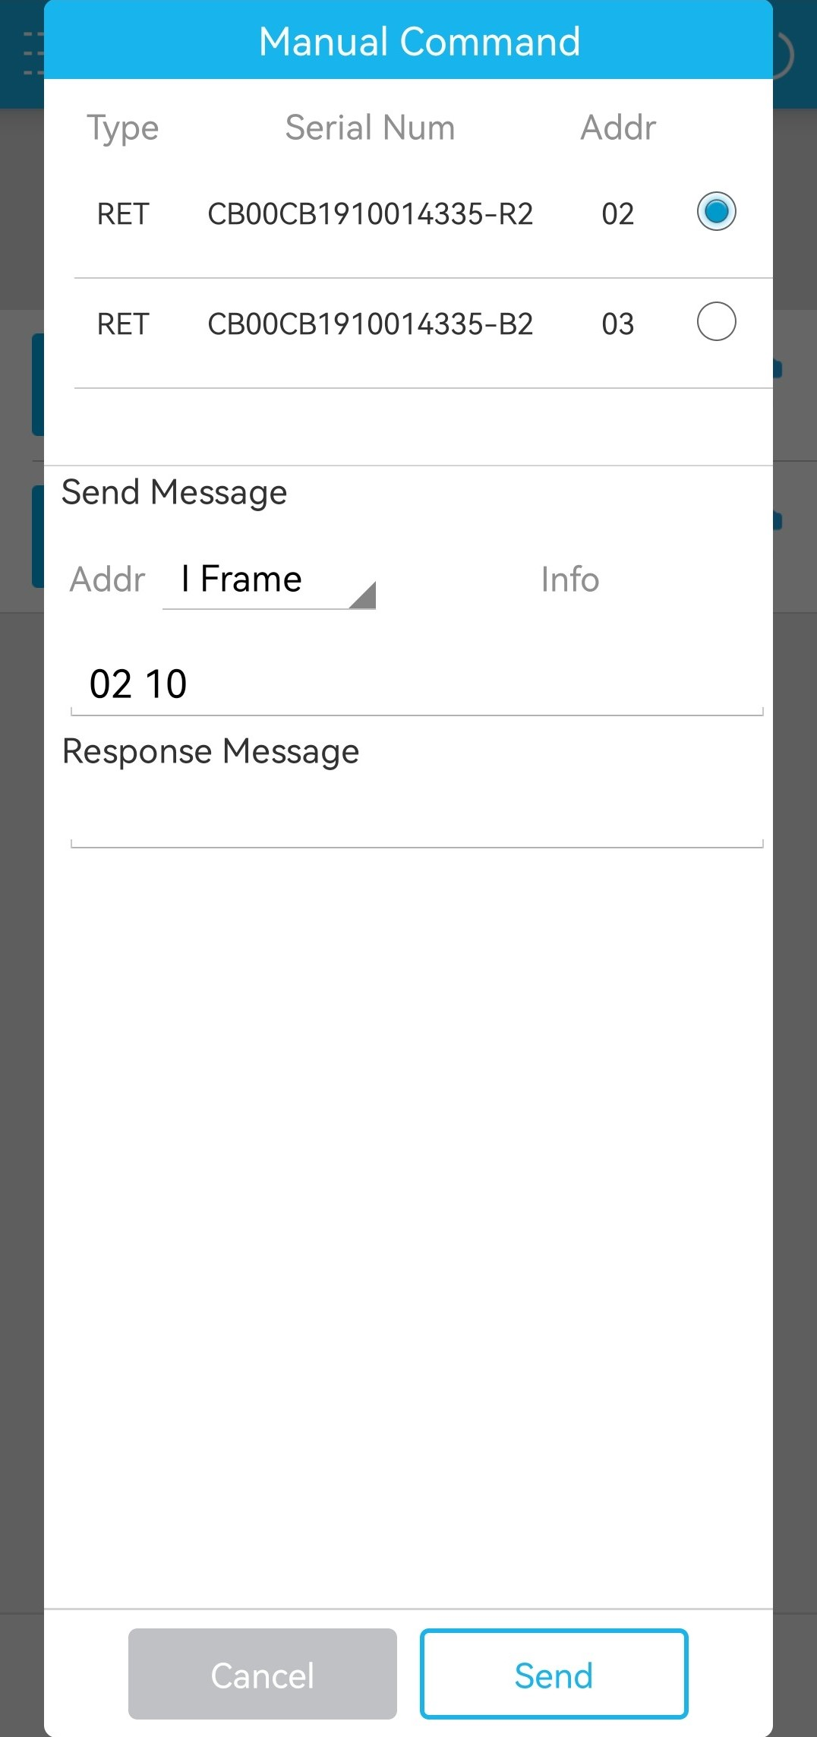
Select the frame type.
Enter the message command.

Help

Function
To obtain the help files of the app
The document is displayed in PDF format, and is saved in the ***/luxpat/help temporary directory. The document name varies according to the region and language of the mobile phone system: user_guide_(language)_(country).pdf. You can open PDF documents only after you install the Adobe Acrobat Reader app on your phone.

Procedure
Tap Help to view the entire help document.
              - Help
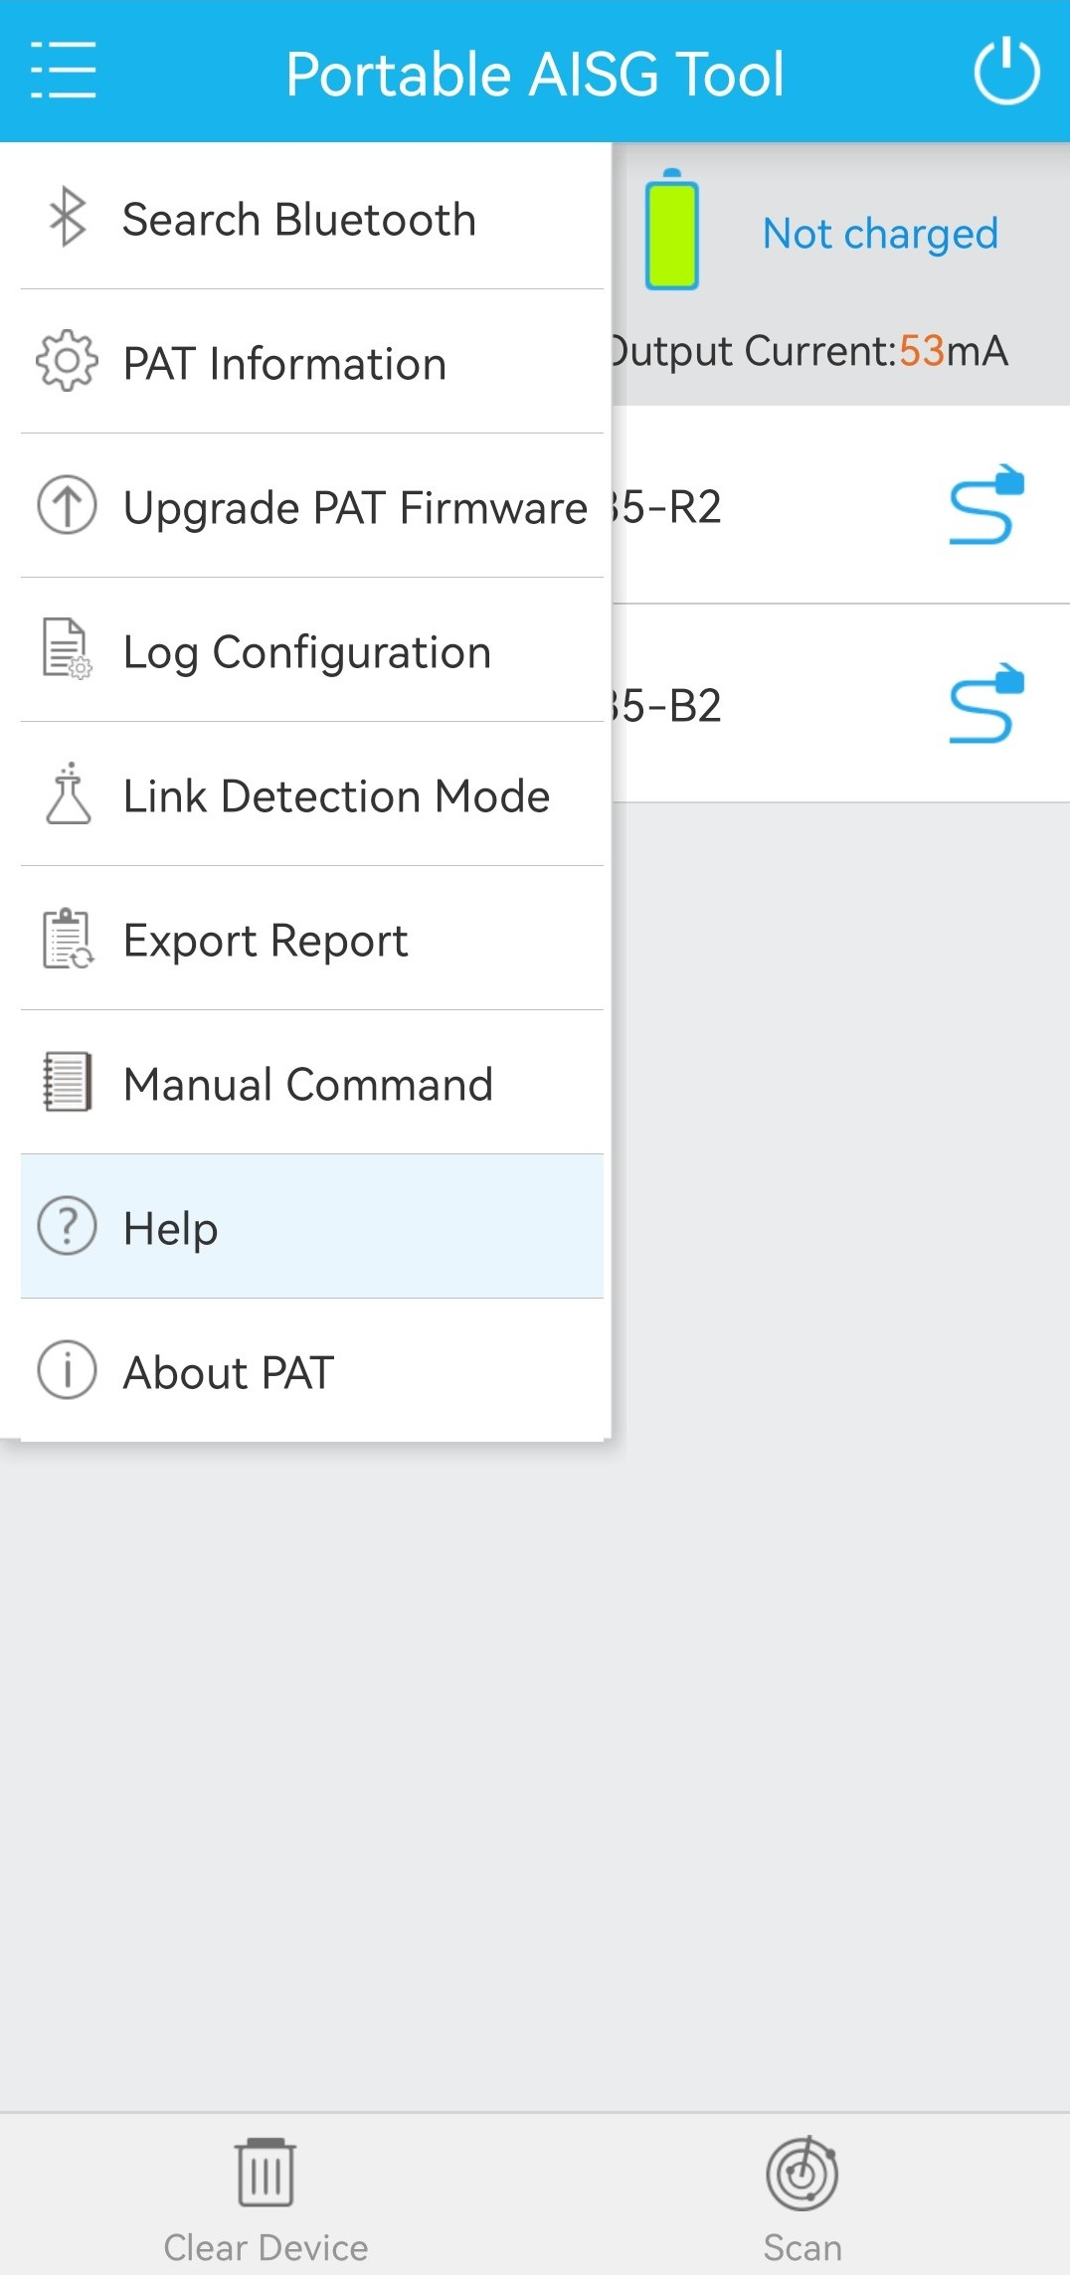

About the PAT
The current software version and the PAT software and hardware versions are displayed, as shown in Figure 4-1.
              - About PAT
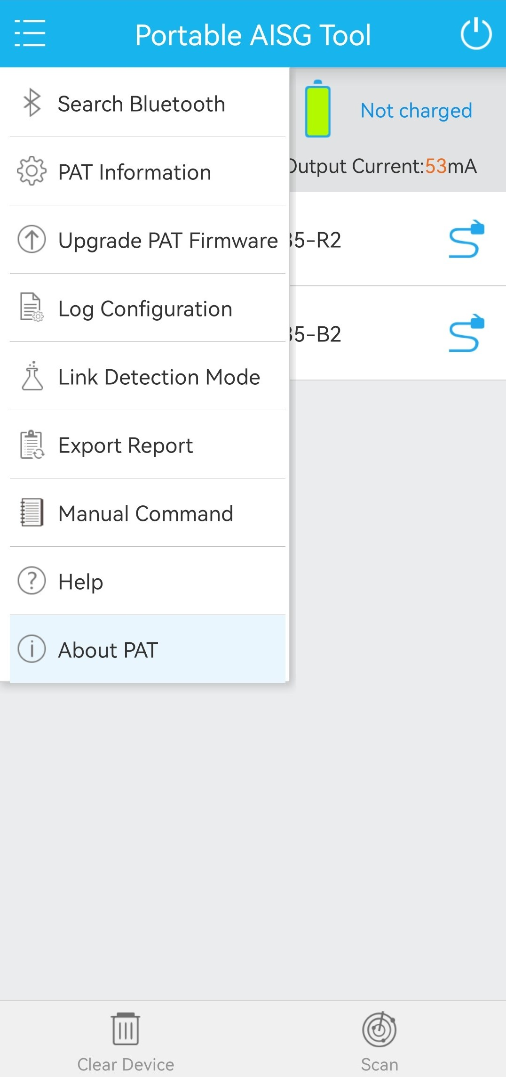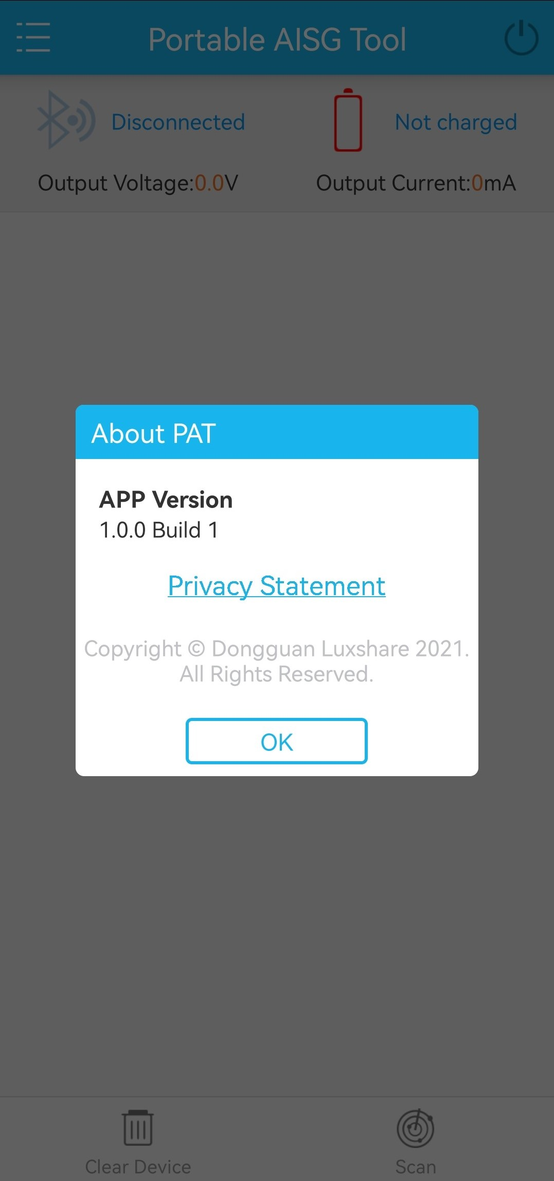

Tap Privacy Statement to get the PAT APP privacy statement.
              - Privacy statement
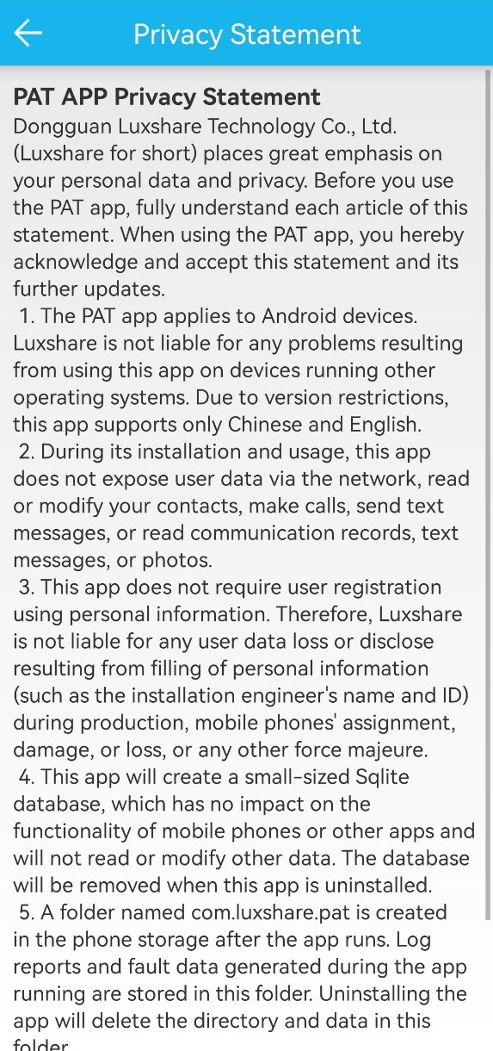

Others

Connect PAT to the ALD
The PAT can be connected to the ALD device through two communication modes.
              - RS485 mode
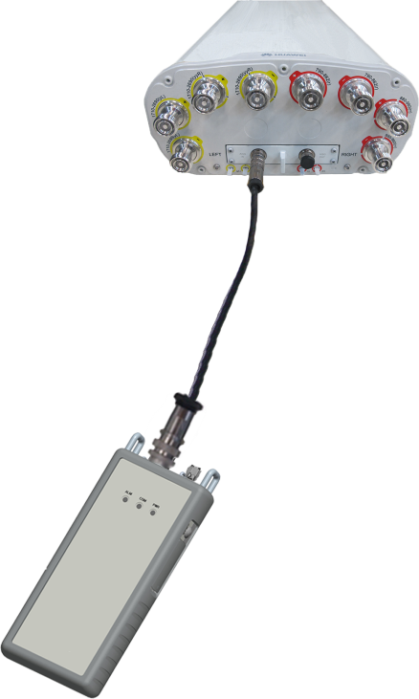
              - OOK mode
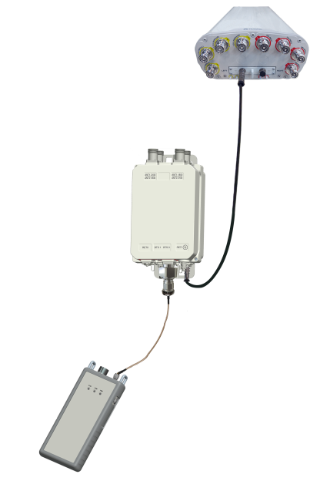

Common Problems
- There is no response after Bluetooth pairing.
Check whether the communication indicator on the PAT is on. If multiple PATs are used, check whether the PAT is the right one displayed on the smartphone.
Confirm whether the mobile phone Bluetooth function is enabled.
- The PAT cannot be powered on.
Recharge the PAT using an AC/DC adapter.
- The PAT cannot be shut down when it is being used.
Hold down the power button to reset the PAT and then try to shut down the PAT again.
- App is not advised to switch to the background when using. especially for time consuming tasks, such as ALD software loading, RET calibration, and RET tilt setting, app may be optimized by the system when switching to the background for a long time, which may cause these processes fail.

Routine Maintenance
During the use and maintenance of the PAT, its battery and shell must be protected.

Battery
The rechargeable battery inside the PAT is a lithium battery. Inappropriate use of the battery may compromise its life cycle or even lead to safety risks.
- The battery cannot be overly recharged or discharged. Otherwise, its life cycle is compromised.
- The PAT must be recharged and discharged at least once every one or two months if it is not used for a long time.
- Please use the right AC/DC adapter.
- If the PAT is used without any external power supply, ensure that the PAT is fully recharged.
- The PAT must not be used or placed near high-temperature sources, such as fire or heaters. Otherwise, the battery may be overheated, disconnected, or even fail, thereby compromising the battery life.
- The PAT cannot be used in places with strong electrostatic and magnetic fields. Otherwise, the battery safety protection unit may be damaged, causing safety issues.
- If the battery becomes smelly, overheated, discolored, or deformed, or any other exception occurs during its use, storage, and recharging, remove the battery from the PAT immediately and stop using the battery.
- The battery may fail if either of the following conditions are met:
- The battery is fully recharged within 2 hours after the recharging starts.
- An alarm indicating low battery power is displayed within 1 hour after the battery is used.
In this case, contact Luxshare technical support to replace the battery.
- The rechargeable battery inside the PAT is provided by the battery supplier specified by Luxshare. If the battery needs to be replaced, contact Luxshare technical support.
Unused batteries must be properly disposed. The electrical polarity can be wrapped up using insulation material to prevent fire.

PAT Shell
The PAT shell is made of PC+ABS materials, and is vulnerable to scratches or breakage.
- The PAT must be kept away from violent collision when it is transported, carried, and stored.
- The PAT must not be used outdoors during a thunderstorm.
- If the PAT is to be used at a high position, it is recommended that the PAT be fastened using a strap or protected with a bag to minimize the possibility that the PAT falls to the ground.
- After the PAT is used, the USB and AISG connection ports need to be protected using dedicated protective caps so that foreign matters cannot enter the PAT.

Silicone Shell
The protective shell of the PAT is made of silicone materials and is vulnerable to scratches or breakage.
- The silicone shell cannot be in contact with keen-edge objects.
- The silicone shell must not be frequently removed or violently stretched. Otherwise, the shell may be deformed.
- It is recommended that the silicone shell be cleaned using wet cloth or a toothbrush with toothpaste or alcohol and then washed using clean water. Do not soak the silicone shell into water for a long time, violently brush the shell, or dry the shell at high temperature using a hair dryer.
- The silicone shell may easily be covered with dust, grease stain, or other foreign matters due to electrostatic attraction. Therefore, it is recommended that the PAT be placed in a paper case at a cool and dry environment if it is not used for a long time.

